

CORERECRUITER: HUMAN RESOURCE MANAGEMENT SYSTEM WITH AI INTEGRATION
BY
FRANK GBADAGO (11232324)
AND
THELMA ASARE (11124414)

DECLARATION
We hereby declare that this project titled 'CoreRecruiter: An AI-Integrated Human Resource Management System' is the result of our original work carried out under the supervision of the Department of Computer Science, University of Ghana.
To the best of our knowledge, this work has not been submitted, either in whole or in part, to any other university or institution for the award of any degree. All sources of information used in this study have been duly acknowledged and referenced in accordance with accepted academic standards.

DEDICATION
This project is dedicated to Almighty God and to our families, lecturers, and friends for their support.

ACKNOWLEDGEMENTS
We thank Almighty God for His guidance, strength, and blessings throughout the successful completion of this project.
Our appreciation also goes to the lecturers and staff of the Department of Computer Science, University of Ghana, for providing the knowledge, skills, and academic environment that made this work possible.
Finally, we extend our heartfelt gratitude to our parents, family members, colleagues, and friends for their continuous encouragement, prayers, understanding, and support throughout our academic journey.

ABSTRACT
CoreRecruiter is an AI-integrated Human Resource Management System that streamlines recruitment through intelligent CV screening, applicant tracking, interview scheduling, employee management, leave management, and HR analytics. The system adopts Design Science Research and Agile methodologies.

TABLE OF CONTENTS
CHAPTER ONE: INTRODUCTION 3
1.1 Introduction 3
1.2 Background of the Study 5
1.3 Research Problem Statement 6
1.4 Research Questions 7
1.5 Research Aims & Objectives 8
1.6 Scope and Limitations of the Study 9
1.7 Research Methodology (Brief) 11
1.8 Organization of the Project 12
CHAPTER TWO: THEORY, BACKGROUND AND REVIEW 13
2.1 Introduction 13
2.2 Theoretical and Conceptual Framework 14
2.2.1 Human Resource Management and the Recruitment Function 14
2.2.2 Electronic Human Resource Management (e-HRM) 15
2.2.3 Technology Acceptance and the Human Factor in HR Systems 16
2.2.4 Person–Job Fit and Person–Organization Fit 17
2.2.5 Artificial Intelligence in Recruitment: Core Technical Concepts 17
2.2.6 Legal and Ethical Considerations: Data Protection 18
2.3 Review of Related Systems and Empirical Studies 20
2.3.1 Manual and Semi-Formal Recruitment Practice in Ghana and the Sub-Region 20
2.3.2 Commercial Applicant Tracking Systems and HRIS Platforms 21
2.3.3 e-HRM and HRIS Adoption in Sub-Saharan Africa 22
2.3.4 AI-Driven Résumé Screening and Candidate Ranking 23
2.3.5 Predictive Analytics and People Analytics in HR 24
2.3.6 Algorithmic Bias, Fairness and Trust in AI Recruitment Tools 24
2.4 Critical Synthesis: Comparative Analysis of Existing Systems 26
2.5 Gaps in Existing Literature and Systems 27
2.6 Enabling Technologies Adopted in This Study 28
2.6.1 A Single Integrated Web Platform Rather than Point Solutions 29
2.6.2 Tool-Calling LLM Agent Architecture for Transparent Screening 29
2.6.3 Cost- and Connectivity-Conscious Delivery 30
2.6.4 Usability for HR Staff with Limited Prior Exposure to HR Software 31
2.7 Conceptual Framework for the Study 31
2.8 Chapter Summary 32
References 34

CHAPTER ONE: INTRODUCTION

1.1 Introduction
Human Resource Management (HRM), the strategic and coherent approach to managing an organization’s workforce across recruitment, onboarding, development, and administration, remains fundamental to organisational performance, since hiring errors and administrative inefficiency propagate downstream costs in training, turnover, and lost productivity that are far more expensive to correct than to prevent. Yet many organizations, particularly small and medium-sized enterprises (SMEs) in developing economies such as Ghana, continue to rely on manual, paper-driven recruitment processes (newspaper advertisements, employee referrals, and unsolicited applications screened by hand) that are slow, subjective, and difficult to audit. At the same time, Artificial Intelligence (AI) has begun to reshape recruitment practice globally through automated résumé screening, candidate ranking, and predictive analytics, offering a route to faster and more consistent hiring decisions where infrastructure and adoption conditions permit it.
This project proposes and implements CoreRecruiter, a centralised, AI-integrated web platform for hiring, employee management, and HR reporting, designed specifically for the Ghanaian organisational context. CoreRecruiter combines an applicant-facing job listing and application portal, an AI-assisted screening and ranking module, an HR administration dashboard, and an employee self-service (ESS) portal into a single system, so that a candidate's data and evaluation history carry forward from application through to active employment rather than being re-entered across disconnected tools.

A number of key terms and constructs recur throughout this study and are defined here for clarity:
Applicant Tracking System (ATS): software that manages the recruitment pipeline (job postings, applications, résumés/CVs, and candidate evaluation) from a single interface.
Human Resource Information System (HRIS) / Electronic HRM (e-HRM): the use of web-based, networked technologies to support HR policy implementation, ranging from simple digitisation of paper processes to systems that actively reshape how HR decisions are made.
Large Language Model (LLM) Agent: a language model given the ability to call external tools or functions (for example, retrieving a job's structured requirements or a candidate's profile data) and to reason over the results before producing a decision, rather than pattern-matching on raw text alone.
Decomposed / Explainable AI Score: a screening score broken down into its constituent criteria (e.g., skills, experience, education) rather than returned as a single opaque number, so that a human reviewer can audit the reasoning behind it.
Person–Job (P–J) Fit and Person–Organization (P–O) Fit: P–J fit is the match between a candidate's skills and a specific role's requirements; P–O fit is the broader congruence between a candidate's values and an organization’s culture. Automated screening is generally better suited to assessing P–J fit, leaving P–O fit to human-mediated interview stages.
Employee Self-Service (ESS): a module that allows employees to independently manage their own attendance, leave, payroll, and document records without routing every request through an HR administrator.
Technology Acceptance Model (TAM): a model explaining system adoption as a function of perceived usefulness and perceived ease of use, both directly relevant to whether HR staff with limited prior exposure to HR software will actually use a new system.

1.2 Background of the Study
Recruitment and selection are widely documented as consequential functions within HRM, yet studies of Ghanaian and wider West African organizations repeatedly find heavy reliance on informal channels (newspaper advertisements, campus recruitment, employee referrals, and unsolicited applications), with only limited and uneven adoption of internet-based or data-driven recruitment methods. Reviews of recruitment practice in the sub-region describe selection processes as often "clouded in subjectivity" and not grounded in objective, criterion-referenced assessment, a pattern attributed to weak HR policy infrastructure, skills shortages among HR practitioners, and slow uptake of HR technology rather than any rejection of digital tools in principle.

Globally, e-HRM in the form of ATS platforms has been shown to improve efficiency, transparency, and decision quality by centralising candidate data and enabling analytics-supported shortlisting. More recently, AI techniques such as natural language processing (NLP) and LLM-agent-based screening have demonstrated significant gains in screening speed and consistency over manual review. However, the dominant commercial ATS and HRIS platforms (e.g., Workday, Greenhouse, BambooHR, Zoho Recruit) are built around enterprise or Western SME assumptions: dollar-denominated pricing, multi-month implementation timelines, and AI features tuned for high-volume, English-language, Western-labour-market résumés. They are also, almost without exception, point solutions: an ATS manages hiring, while a separate HRIS or payroll system manages the employee once hired, requiring organizations to integrate, or manually reconcile, two disconnected systems. Regional efforts such as SeamlessHR show that an integrated, Africa-focused model is commercially viable, but as proprietary products their screening methodology is not published for independent scrutiny, leaving no documented, auditable rubric against which a Ghanaian organization could verify that an AI screening tool's judgements are consistent and free of bias.

At the same time, adoption research specific to Sub-Saharan Africa, covering HRIS uptake among SMEs and e-HRM implementation in the public sector, consistently identifies cost of acquisition, unstable ICT infrastructure, and limited digital literacy among HR staff as the binding constraints on adoption, rather than any rejection of digitalisation itself. Compounding this, once a candidate is hired, many Ghanaian SMEs continue to manage attendance, leave, payroll, and complaints manually or through generic spreadsheets, extending the same inefficiency past the point of hire.

This study is motivated by the resulting gap: existing systems that are technically capable of AI-assisted, integrated recruitment and HR management are either not designed for Ghanaian cost and infrastructure constraints, or do not expose their AI screening logic in a way that HR staff and candidates can trust and audit. CoreRecruiter is proposed as a response to that specific gap, not as a generic claim that "AI improves hiring."

1.3 Research Problem Statement
Ghanaian organizations, particularly SMEs, lack access to a recruitment and HR platform that is simultaneously (a) integrated across the full hiring-to-employment lifecycle, (b) transparent in how any AI-assisted screening arrives at its recommendations, and (c) realistic in cost and technical complexity for organizations without a dedicated IT department. This produces the following recurring problems:
Job postings, applications, and candidate evaluation are managed through informal or manual channels, making hiring slow, subjective, and difficult to audit.
Where AI screening tools exist, they are largely developed for enterprise, non-Ghanaian markets, and typically return an aggregate match score without decomposing it into criteria an HR user could independently inspect, undermining trust and inviting the "illusion of neutrality" documented in recent audits of commercial AI hiring tools.
Applicant and candidate data captured during recruitment is not carried forward into the employee record once a candidate is hired, forcing duplicate data entry during onboarding and severing the link between screening history and employee performance data.
HR administrators lack a single dashboard to manage departments, employees, interviews, leave, payroll, and complaints, leading to fragmented oversight.
Employees have limited or no self-service access to their own attendance, leave, payroll, and document records, increasing the administrative burden on HR staff for routine requests.
Commercial platforms capable of addressing (1)–(4) assume enterprise budgets, stable high-bandwidth connectivity, and dedicated IT support (conditions not typically available to Ghanaian SMEs), while systems priced for this market tend to offer little or no AI-assisted screening.
The central problem this project addresses is: how can an integrated, AI-assisted recruitment and human resource management platform be designed and built for the Ghanaian SME context, such that its AI screening is transparent and auditable, its cost and technical footprint are realistic for resource-constrained organizations, and applicant data carries forward seamlessly into post-hire employee administration?

1.4 Research Questions
This study is guided by the following questions:
- What workflow gaps exist between manual recruitment practice and post-hire employee administration in Ghanaian SMEs, and what do they cost in time, consistency, and auditability?
- What features are necessary for an integrated recruitment and HR platform to serve three distinct user groups (applicants, HR administrators, and employees) within the cost and infrastructure constraints typical of the Ghanaian SME context?
- How can AI-assisted candidate screening be designed so that its scoring is decomposed and explainable to an HR reviewer, rather than returned as an opaque aggregate score?
- How can a single data model carry an applicant's information and screening history forward through onboarding into an active employee record without duplication?
- What role-based access, authentication, and data-handling mechanisms are required to secure applicant and employee data in line with Ghana's Data Protection Act, 2012 (Act 843)?
- To what extent can an integrated self-service (ESS) module reduce the manual administrative workload placed on HR personnel after hiring?

1.5 Research Aims & Objectives
Aim: To design and develop CoreRecruiter, an integrated, AI-assisted, web-based recruitment and human resource management platform that unifies the applicant journey, transparent AI-assisted screening, HR administration, and employee self-service into a single system suited to the Ghanaian SME context.

Specific Objectives:

- To review existing recruitment and HRIS tools, AI-driven screening approaches, and the relevant theoretical literature (e-HRM, Technology Acceptance Model, Person–Job/Person–Organization Fit) to identify the gaps between standalone applicant-tracking systems and standalone HR systems, and between existing AI screening tools and the transparency such screening requires to be trustworthy.
- To design a system architecture and data model that allows an applicant record, including its AI screening history, to transition into an employee record without re-entry of data.
- To implement a job listing and application module through which applicants can browse vacancies, submit applications, and track application status.
- To implement an AI-assisted screening and candidate-ranking module using a tool-calling LLM agent that retrieves structured job requirements and candidate profile data and returns a decomposed, explainable score (covering skills, experience, education, and role-specific criteria) rather than a single opaque figure.
- To implement an HR administration dashboard covering departments, employees, job postings, interview scheduling, applicant evaluation, leave, payroll, announcements, and reporting.
- To implement an employee self-service (ESS) module covering attendance, leave requests, payroll/payslip viewing, document uploads, and complaint reporting.
- To implement authentication, role-based access control, and data-handling practices consistent with Ghana's Data Protection Act, 2012 (Act 843), separating applicant, employee, and HR administrator permissions.
- To evaluate the resulting system against the stated objectives through functional testing and, where feasible, usability assessment with prospective HR users.

1.6 Scope and Limitations of the Study
Scope: The study covers the design and implementation of a web application with three user-facing surfaces (an applicant/job-seeker portal, an HR administrator dashboard, and an employee self-service portal), together with an AI-assisted screening and ranking module and the supporting authentication, onboarding, and notification functionality that connects them. The system is built as a Next.js (TypeScript) frontend backed by a modular Node.js/TypeScript backend covering authentication, job and applicant management, AI screening, employee management, onboarding, ESS, HR administration, and notifications, and is evaluated primarily against the needs of Ghanaian SME organizations.

Limitations:
- The project is developed and evaluated within an academic timeframe and budget, so it targets core recruitment-to-HR workflows and a defined AI screening rubric rather than every feature found in enterprise HRMS products (e.g., multi-jurisdiction payroll tax compliance, deep third-party payroll integrations).
- Testing is conducted primarily with simulated applicant and employee data rather than a live, multi-organization production deployment, so adoption and infrastructure-resilience claims are treated as hypotheses for future evaluation rather than proven outcomes.
- AI screening in this study is scoped to Person–Job fit (skills, experience, education, and stated nice-to-have criteria); Person–Organization fit is deliberately left to human interviewers, consistent with the literature's caution against relying on automated assessment for judgements it is poorly positioned to make.
- The system assumes a single organization’s HR structure at a time (departments, roles, and policies configured per company) rather than multi-tenant SaaS-scale isolation.
- Decomposing and exposing the AI score's reasoning mitigates, but does not eliminate, the risk of algorithmic bias; ongoing bias monitoring beyond the scope of this project would be required for production-scale deployment.
- Mobile-native applications are out of scope; the system is delivered as a responsive web application.

1.7 Research Methodology (Brief)
This project follows an iterative, Agile-inspired software development methodology, comprising:
Requirements gathering and literature review: identifying the core workflows needed by three user roles (applicants, HR administrators, and employees) and grounding the AI screening design in the e-HRM, TAM, and algorithmic-fairness literature reviewed in Chapter Two.
System design: producing the data model, module breakdown (authentication, job/applicant management, AI screening and ranking, onboarding, employee management, ESS, HR-admin, notifications), and the decomposed AI scoring rubric that connects recruitment to post-hire administration.
Implementation: building the system incrementally using a Next.js/TypeScript frontend (App Router, Tailwind CSS, shadcn/ui) and a modular Node.js/TypeScript backend, with a tool-calling LLM agent implementing the AI screening module, and each module developed and integrated iteratively.
Testing: functional testing of each module as it is completed, followed by integration testing across the applicant-to-employee workflow and consistency testing of the AI screening component.
Evaluation: assessing the completed system against the research objectives stated in Section 1.5.
Full methodological detail, including tools, design diagrams, the AI scoring rubric, and testing procedures, is presented in Chapter Three.

1.8 Organization of the Project
This project report is organized into five chapters:
- Chapter One: Introduction presents the background, problem statement, research questions, aims and objectives, scope and limitations, and a brief overview of the methodology used in this study.
- Chapter Two: Theory, Background and Review examines the theoretical foundations (HRM theory, the Technology Acceptance Model, Person–Job/Person–Organization Fit theory, and the technical concepts underpinning AI-assisted screening), critically reviews empirical studies and commercial systems relevant to e-recruitment, HRIS, and AI-driven hiring (with particular attention to Ghana and comparable Sub-Saharan African economies) and synthesises this material into the specific gaps CoreRecruiter is designed to close.
- Chapter Three: Methodology and System Design details the software development methodology, system requirements, architecture, data model, AI screening rubric, and design artifacts (use case diagrams, entity-relationship diagrams, and interface designs) used to build the system.
- Chapter Four: Implementation and Results describes how the system was implemented, the tools and technologies used, and presents the results of functional testing across the applicant, HR administrator, and employee-facing modules, including evaluation of the AI screening component.
- Chapter Five: Summary, Conclusion, and Recommendations summarizes the findings of the project, evaluates the extent to which the stated objectives were achieved, discusses limitations encountered during development, and offers recommendations for future work.

CHAPTER TWO: THEORY, BACKGROUND AND REVIEW

2.1 Introduction
Chapter One established that Human Resource Management (HRM) remains fundamental to organisational performance, yet many organizations, particularly small and medium-sized enterprises (SMEs) in developing economies such as Ghana, continue to rely on manual, paper-driven recruitment processes that are slow, subjective and difficult to audit. It further noted that Artificial Intelligence (AI) has begun to reshape recruitment practice globally through automated resume screening, candidate ranking and predictive analytics, and proposed CoreRecruiter as a centralised, AI-integrated web platform for hiring, employee management and HR reporting in the Ghanaian context. This chapter interrogates that proposition against the existing body of theory, empirical research and commercial practice.
The chapter is organised in six substantive parts. Section 2.2 lays out the theoretical and conceptual foundations that underpin electronic recruitment and AI-assisted hiring: Human Resource Management theory, the Technology Acceptance Model (TAM), Person–Job and Person–Organization Fit theory, and the technical concepts (natural language processing, large language model agents, scoring and ranking) that make automated screening possible. Section 2.3 critically reviews empirical studies and commercial systems relevant to e-recruitment, Human Resource Information Systems (HRIS) and AI-driven hiring, with particular attention to evidence from Ghana and comparable Sub-Saharan African economies. Section 2.4 synthesises this material into a comparative analysis of existing platforms. Section 2.5 distils the gaps that this literature exposes. Section 2.6 reviews the specific technologies adopted to close those gaps in CoreRecruiter, and Section 2.7 draws the chapter together into a conceptual framework that motivates the system design presented in Chapter Three. Throughout, the review avoids treating cited sources as a mere catalogue; instead, studies are placed in dialogue with one another so that points of agreement, contradiction, and unresolved tension can inform the design decisions taken later in this study.

2.2 Theoretical and Conceptual Framework

2.2.1 Human Resource Management and the Recruitment Function
Human Resource Management is conventionally defined as the strategic and coherent approach to the management of an organization’s workforce, encompassing recruitment, selection, development, performance management, compensation and separation. Within this function, recruitment and selection occupy a privileged position because hiring errors propagate downstream costs in training, turnover and lost productivity that are far more expensive to correct than to prevent. In the Ghanaian and wider West African context, empirical work on recruitment practice has repeatedly found that firms rely heavily on informal channels (newspaper advertisements, employee referrals, campus recruitment and unsolicited applications) with comparatively limited adoption of internet-based or data-driven recruitment methods, even as such channels expand globally. This pattern is not confined to Ghana: reviews of recruitment and selection practice in Nigerian institutions describe processes as “clouded in subjectivity” and not grounded in objective, criterion-referenced assessment, while broader continental assessments attribute persistent inefficiency to a combination of weak HR policy infrastructure, skills shortages among HR practitioners, and slow uptake of HR technology. Read together, these studies support the premise in Chapter One that manual recruitment inefficiency is not an isolated or anecdotal problem in the Ghanaian labour market but a documented, cross-country feature of HRM practice in the sub-region, which is precisely the condition CoreRecruiter is designed to address.

2.2.2 Electronic Human Resource Management (e-HRM)
Electronic HRM (e-HRM) refers to the use of web-based and networked technologies to support HR policy implementation, ranging from simple digitisation of paper processes (“operational e-HRM”) to systems that actively reshape how HR decisions are made (“relational” and “transformational” e-HRM). A widely cited four-decade review of e-HRM research observes that although the field has matured considerably, much of the literature still treats e-HRM adoption and its organisational consequences as separate research streams, with comparatively few studies tracing a specific system from adoption through to measurable HR outcomes. This is a methodological gap this study takes seriously: rather than treating “adoption” and “impact” as disconnected questions, CoreRecruiter is conceived and will be evaluated as a single socio-technical intervention whose usability, adoption and downstream effect on hiring quality are interdependent. Applied specifically to recruitment, e-HRM in the form of Applicant Tracking Systems (ATS) has been shown to improve efficiency, transparency and decision quality by centralising candidate data, standardising evaluation templates and enabling analytics-supported shortlisting, though the same body of work cautions that these gains are conditional on adequate ICT skills among HR users, stable infrastructure and sound data-governance practice, conditions that cannot be assumed in many Ghanaian organisational settings.

2.2.3 Technology Acceptance and the Human Factor in HR Systems
The Technology Acceptance Model (TAM) explains user adoption of information systems as a function of two beliefs: perceived usefulness and perceived ease of use, both of which shape attitude toward use and, in turn, actual system usage. Because TAM was formulated for general information systems, subsequent HR-specific research has extended it to explain e-HRM acceptance in particular, finding that perceived usefulness, ease of use, user satisfaction and organisational context (notably whether the adopting firm is IT-intensive or not) jointly determine whether HR staff actually use an e-HRM system as intended rather than reverting to informal workarounds. This has direct design implications for CoreRecruiter: studies of HRIS adoption in Sub-Saharan African SMEs consistently identify limited digital literacy among HR staff, and specifically among older or less formally trained employees, as one of the strongest barriers to sustained use, alongside the high cost and technical complexity of enterprise-grade systems. A platform that is technically capable but difficult to learn is therefore unlikely to achieve the adoption on which any efficiency gain depends, which is why usability for HR staff with limited prior exposure to HR software is treated in this study as a design requirement rather than a secondary concern.

2.2.4 Person–Job Fit and Person–Organization Fit
Selection theory distinguishes Person–Job (P–J) fit, the match between an individual's knowledge, skills and abilities and the requirements of a specific role, from Person–Organization (P–O) fit, the broader congruence between an individual's values and goals and those of the organization. The foundational integrative review of P–O fit and the subsequent meta-analysis of fit's consequences across levels (job, organization, group and supervisor) both find that better-fitting hires report higher job satisfaction, stronger organisational commitment and lower turnover intention, which is precisely the outcome chain that justifies investing in more rigorous screening at the point of hire rather than treating selection as a purely administrative filter. In automated recruitment systems, P–J fit is typically operationalised at the initial screening stage through structured matching of skills, experience and qualifications against stated job requirements, while P–O fit, being harder to infer from a résumé, is reserved for later, human-mediated stages such as interviews. This distinction motivates a deliberate scope decision in CoreRecruiter's AI screening design: the automated component is scoped to P–J fit (skills, experience, education, and role-specific “nice-to-have” criteria), while P–O fit judgements are explicitly left to human reviewers at interview stage, rather than allowing an algorithm to make a determination the literature suggests it is poorly positioned to make.

2.2.5 Artificial Intelligence in Recruitment: Core Technical Concepts
Three technical concepts recur across AI-recruitment literature and are directly relevant to this study. First, automated résumé screening historically relied on keyword and Boolean matching, but recent systems increasingly use natural language processing (NLP) and transformer-based language models to perform semantic matching, recognising that “led a team of five engineers” and “managed a small engineering team” express comparable experience even though they share few keywords. Second, Large Language Model (LLM) agents extend this further by combining a language model with the ability to call external tools or functions (for example, retrieving a job's structured requirements or a candidate's verified profile data) and reasoning over the results before producing a final judgement, rather than pattern-matching on raw text alone. A 2024 framework applying LLM agents to résumé screening reports screening roughly eleven times faster than manual review, with the fine-tuned classification component achieving an F1 score of 87.73% and outperforming a raw GPT-3.5 baseline, evidence that structuring an LLM's task with explicit sub-steps (summarise, grade, decide) measurably improves both speed and accuracy over an undirected prompt. Third, candidate ranking converts individual screening scores into an ordered shortlist, which is only as trustworthy as the scoring rubric beneath it, a point developed further in Section 2.3.6. These three concepts (semantic matching, tool-augmented agent reasoning, and rubric-based ranking) together describe the technical approach that CoreRecruiter's AI screening module adopts, and are revisited in Section 2.6 with specific reference to its implementation.

2.2.6 Legal and Ethical Considerations: Data Protection
Because a system such as CoreRecruiter necessarily processes sensitive personal data (candidate résumés, national identification and salary expectations at the recruitment stage, and payroll, attendance and leave records once an employee is hired), its design cannot be treated as a purely technical exercise separate from Ghana's statutory data protection regime. The Data Protection Act, 2012 (Act 843) establishes the Data Protection Commission as the independent body responsible for regulating the collection, processing, storage and disclosure of personal data by public and private organizations in Ghana, requires data controllers to register before processing personal data, and codifies eight data protection principles (including purpose limitation, data minimisation, and the data subject's right to be informed, to access, and to correct their own data) enforceable through both civil and, in serious cases, criminal sanction. This has two direct implications for the present study. First, it constrains what CoreRecruiter's AI screening component may legitimately do with candidate data: the Act's purpose-limitation principle means profile and CV data collected for an application to one role cannot be silently repurposed for unrelated automated decision-making without a lawful basis, which is one reason the screening design in Section 2.6.2 deliberately restricts the model to data explicitly tied to the specific job and application being evaluated rather than a candidate's entire historical footprint on the platform. Second, it means that an explainable, decomposed AI score (the same design response motivated on fairness grounds in Section 2.3.6) also serves the Act's access and correction rights more directly than an opaque aggregate score would, since a candidate exercising a right to understand a decision made about their data is better served by a system that can state which criteria drove the outcome. Data protection compliance is therefore treated in this study not as an external legal formality layered on afterward, but as a further, independent justification for the transparency requirement that recurs throughout this chapter.

2.3 Review of Related Systems and Empirical Studies

2.3.1 Manual and Semi-Formal Recruitment Practice in Ghana and the Sub-Region
A multi-case study of five firms in Accra, Kumasi and Tema examined recruitment and selection practice through in-depth interviews and document analysis, and found substantial convergence across firms in reliance on newspaper advertisements, campus recruitment, employee referrals and unsolicited applications, with only limited and uneven adoption of internet-based or social-media recruitment, and selection techniques such as psychometric testing and assessment centres applied inconsistently depending on role seniority and industry. This is consistent with continental evidence that traditional recruitment channels persist in many African organizations despite the global shift toward digital hiring, and it is corroborated by an East African study of e-HRM's effect on recruitment and selection effectiveness, which found that where digital tools are used, they measurably improve decision quality through structured, competency-based assessment, centralised candidate databases and consistent scoring templates, but that adoption remains constrained by limited ICT skills, infrastructure instability and data-governance weaknesses among HR users. The pattern that emerges across this literature is not that digital recruitment tools are unwanted or ineffective in the Ghanaian and East African context, but that the systems available to date have not been designed around the constraints (cost, connectivity, and HR staff digital literacy) that actually shape adoption in this setting.

2.3.2 Commercial Applicant Tracking Systems and HRIS Platforms
Globally, the ATS and HRIS market is dominated by platforms such as Workday, Greenhouse, Lever, SmartRecruiters, BambooHR and Zoho Recruit, each occupying a distinct position on complexity and cost. Workday and Greenhouse target enterprise clients requiring deep integration with broader human capital management (HCM) suites and role-based governance, with implementation timelines commonly cited at three to six months; SmartRecruiters and Lever sit in a mid-market tier with extensive third-party integration marketplaces (over 300 integrations each); and BambooHR and Zoho Recruit target smaller organizations, trading deep customisability for faster time-to-value, though reviewers note that Zoho Recruit's interface complexity and limited customisation, and BambooHR's comparatively light workflow flexibility, become constraining once an organization’s hiring process diverges from the vendor's assumed template. None of these platforms was designed with the Ghanaian or wider West African SME in mind: their pricing models assume dollar- or pound-denominated enterprise budgets, their AI features are optimised for high-volume, English-language, Western-labour-market résumés, and, critically for this study, they are predominantly point solutions for the hiring pipeline, requiring separate integration with a distinct HRIS or payroll system to manage the employee once hired. A regional counter-example, SeamlessHR, has emerged specifically to serve Ghana, Nigeria and Kenya with a combined HR and ATS suite, which is itself evidence that the African market has recognised demand for the kind of integrated, regionally grounded platform CoreRecruiter proposes, though as a proprietary commercial product its internal screening methodology and evidentiary basis are not published for independent academic scrutiny, a transparency gap this study addresses directly by documenting CoreRecruiter's scoring rubric in full (Section 2.6).

2.3.3 e-HRM and HRIS Adoption in Sub-Saharan Africa
A stream of empirical work has examined why HRIS and e-HRM adoption in African organizations lags behind global averages despite documented efficiency benefits. A study of HRIS adoption among SMEs in Cameroon, using the Unified Theory of Acceptance and Use of Technology (UTAUT), found that performance expectancy and internal social influence (essentially, whether colleagues and supervisors are seen to endorse the system) were the strongest predictors of adoption intention, with age and education level moderating the relationship between intention and actual use. An empirical study of e-HRM implementation in public-sector organizations in an emerging economy similarly found that organisational readiness, top-management support and perceived ease of use jointly determined implementation success, and explicitly flagged infrastructural instability and limited technical skill among public-sector HR staff as recurring obstacles. A broader review of HRIS in developing countries situates these single-country findings within a wider pattern: cost of acquisition and maintenance, weak ICT infrastructure, and workforce resistance (particularly from older or less formally educated staff who perceive the system as incomprehensible, and paradoxically from more highly educated staff whose expectations the system fails to meet) are the most frequently cited barriers across the literature. Taken together, these studies converge on a consistent explanation for low HRIS uptake in the region that is rarely, if ever, a rejection of digitalisation itself, but rather a mismatch between the cost, complexity and support model of available systems and the operating conditions of the organizations expected to adopt them. This is the specific adoption problem CoreRecruiter is positioned to solve, rather than a generic claim that “AI improves hiring.”

2.3.4 AI-Driven Résumé Screening and Candidate Ranking
Beyond the LLM-agent framework discussed in Section 2.2.5, a systematic review of AI techniques for addressing algorithmic bias in hiring surveyed both the promise and the documented failure modes of automated screening, concluding that natural-language-processing techniques such as vector-space debiasing and data augmentation are among the more effective mitigation strategies currently available, but that no single technique eliminates bias outright; mitigation must be treated as an ongoing design discipline rather than a one-time fix. Industry-facing evidence, while methodologically less rigorous than peer-reviewed research and interpreted cautiously here, reports efficiency gains in the same range (time-to-hire reductions in the order of 70–80% and cost reductions in a comparable range) when AI screening is introduced without a corresponding decline in candidate quality, which at minimum indicates the direction of the claimed benefit is consistent with the peer-reviewed literature even if the precise magnitude should be treated with caution outside controlled research settings. What is comparatively under-examined in this literature, however, is a screening rubric that is fully transparent to the hiring organization at the point of decision: most published systems report an aggregate match score without decomposing it into the criteria a human recruiter could independently audit, which is precisely the gap Section 2.3.6 and Section 2.6 address.

2.3.5 Predictive Analytics and People Analytics in HR
A related but distinct strand of literature examines HR analytics applied after hiring (to retention, performance and workforce planning) rather than at the point of selection. Recent work evaluating a predictive analytics platform's contribution to talent retention finds that models trained on historical HR data can meaningfully forecast attrition risk and inform proactive retention interventions, reinforcing the broader argument that HR decision-making benefits from being grounded in continuously collected, structured data rather than periodic, manually compiled reports. This has a direct architectural implication for CoreRecruiter: because the platform is designed to capture applicant, employee, attendance, leave and payroll data within a single system rather than across disconnected tools, it is structurally positioned to extend from AI-assisted screening at the point of hire toward this kind of predictive, retention-oriented analytics later in the employee lifecycle, a capability that stand-alone ATS products, by design, cannot offer without external data integration.

2.3.6 Algorithmic Bias, Fairness and Trust in AI Recruitment Tools
The most consequential critique of AI-driven hiring in the current literature concerns bias and opacity, and it must be engaged directly rather than treated as a caveat. Documented cases (most prominently Amazon's discontinued internal recruiting tool, which was found to penalise résumés associated with women) established early that models trained on historical hiring data reproduce the demographic skew of that history. More recent, methodologically rigorous work has sharpened this concern considerably: a 2025 audit of eight major AI hiring platforms found complex, intersectional racial and gender biases, with some models penalising candidates for the mere presence of demographic signals in a résumé, and, more troublingly for systems that appear unbiased on aggregate metrics, found that some models achieving superficially neutral outcomes did so not because they were fair, but because they were incapable of substantive evaluation and fell back on shallow keyword matching, a phenomenon the authors term the “illusion of neutrality.” This finding is significant for the present study because it reframes the design problem: the objective is not merely to produce a score that looks unbiased in aggregate, but to produce a score that is demonstrably grounded in job-relevant evidence and can be inspected, criterion by criterion, by a human reviewer. Complementing this, applicant-perception research surveying over 1,300 participants across seven studies found that while overall procedural fairness perceptions of algorithmic recruitment tools are mixed, perceptions specific to behavioural control and social presence are consistently negative (applicants feel they cannot influence an algorithmic outcome the way they could a human one, and perceive a loss of interpersonal warmth), which suggests that even a technically fair system can be experienced as illegitimate if its reasoning is not made visible to the people it evaluates. A 2025 strategic-HRM analysis further argues that managing algorithmic bias should be treated as an organisational capability requiring governance, monitoring and human oversight, not a property that can be engineered into a model once and left unmonitored thereafter. Read together, this literature yields three design obligations that recur throughout the rest of this chapter: automated scores must be decomposed and explainable rather than a single opaque number; scoring must be grounded in retrievable, job-specific evidence rather than free-text pattern matching alone; and a human decision-maker must remain in the loop at the point where a hiring outcome is finalised.

2.4 Critical Synthesis: Comparative Analysis of Existing Systems
Table 2.1 synthesises the systems and evidence reviewed above along the dimensions that this study's problem statement identifies as decisive for a Ghanaian HR context: whether hiring and post-hire employee management are integrated in one system or require separate tools; whether AI screening is offered at all, and if so, whether its reasoning is exposed to the HR user or returned as an opaque score; and whether the platform's cost and implementation model is realistic for a resource-constrained SME rather than assuming an enterprise budget and dedicated IT department.
Table 2.1: Comparative Analysis of Existing Recruitment and HR Systems
System / Study | ATS + HRIS integration | AI screening transparency | Fit for Ghanaian SME context
Workday / Greenhouse | HCM-integrated, enterprise scope | Limited public detail on scoring logic | Poor: enterprise pricing, 3–6 month implementation
BambooHR / Zoho Recruit | Partial (HR-record linked, limited ATS depth) | Minimal AI or opaque matching score | Moderate: lower cost, but rigid workflows
SeamlessHR | Combined HR + ATS suite | Not published for academic scrutiny | Good: built for the West African market
LLM-agent screening research (Gan et al., 2024) | Not a deployed product; research framework only | Decomposed grading and reasoning steps demonstrated in research | N/A: proof of concept, not localised or deployed
CoreRecruiter (this study) | Single platform: recruitment, onboarding, ESS, payroll, leave | Rubric-decomposed score (skills/experience/education/nice-to-have) with strengths, gaps and salary flag | Designed for Ghanaian SME cost and connectivity constraints
The comparison makes the positioning of this study explicit. Enterprise ATS platforms solve screening at a scale and cost that is inaccessible to the majority of Ghanaian organizations documented in the studies reviewed in Section 2.3.3; regional HR suites such as SeamlessHR demonstrate that an integrated, Africa-focused model is commercially viable but do not publish the screening methodology required for independent evaluation; and the academic LLM-agent literature demonstrates the technical feasibility of transparent, decomposed AI screening but has not, to this study's knowledge, been deployed as part of an integrated, regionally grounded HR platform. CoreRecruiter is positioned at the intersection of these three gaps rather than as an incremental improvement on any one of them.

2.5 Gaps in Existing Literature and Systems
Synthesising Sections 2.3 and 2.4, five specific gaps can be identified that this study responds to directly, rather than treating “manual recruitment is inefficient” as a sufficient justification on its own:
- Fragmentation between recruitment and employee management. The reviewed commercial systems are predominantly point solutions (an ATS handles hiring, a separate HRIS or payroll system handles the employee thereafter), which the e-HRM literature's call for holistic, lifecycle-level system evaluation (Bondarouk et al., 2017) suggests is a conceptual as well as a practical shortcoming.
- Cost and infrastructure mismatch for African SMEs. Adoption studies from Cameroon, and public-sector e-HRM research from a comparable emerging economy, consistently identify cost, infrastructure instability and limited ICT skill as the binding constraints on HRIS adoption, yet the dominant commercial platforms reviewed in Section 2.3.2 are priced and designed around enterprise, high-connectivity assumptions.
- Opaque AI scoring. The bias and fairness literature reviewed in Section 2.3.6 converges on the need for decomposed, auditable scoring rather than a single aggregate match percentage, yet most commercial and research systems reviewed either do not publish their scoring logic or return an undecomposed score.
- Limited empirical grounding in the Ghanaian context specifically. While Ghana- and East Africa-specific studies exist (Amoako et al., 2023; Twinamasiko, 2026; the five-firm Ghanaian study reviewed in Section 2.3.1), they examine recruitment practice and e-HRM adoption in general terms; none evaluates an integrated AI-screening-plus-HRIS platform built and tested specifically for this market.
- Absence of a documented, criterion-referenced rubric suitable for local validation. Because published commercial systems do not expose their scoring methodology, no baseline exists against which a Ghanaian organization, researcher, or regulator could independently assess whether an AI screening tool's judgements are consistent, explicable and free of the “illusion of neutrality” identified in recent audits (Webster, 2025).

2.6 Enabling Technologies Adopted in This Study
The technology choices underlying CoreRecruiter are presented here not as a neutral implementation detail but as a direct, evidence-based response to the gaps identified in Section 2.5, and are described in fuller technical detail in Chapter Three.

2.6.1 A Single Integrated Web Platform Rather than Point Solutions
CoreRecruiter is built as one application spanning recruitment (job listings, applications, AI screening and ranking, interview scheduling), onboarding, employee self-service (attendance, leave, payroll, document management, complaint reporting) and HR administration (departments, announcements, reporting, role-based permissions), sharing a single data model. This directly answers the fragmentation gap identified in Section 2.5: a candidate's screening record, once hired, becomes the same employee record used for onboarding and subsequent HR processes, rather than requiring re-entry into a second system, the specific integration failure the reviewed commercial ATS products do not solve.

2.6.2 Tool-Calling LLM Agent Architecture for Transparent Screening
Rather than a fine-tuned classifier returning a single opaque score, CoreRecruiter implements AI screening as a tool-calling agent: the model is instructed to retrieve the job's structured requirements and the candidate's structured profile and submitted CV through explicit function calls before producing a verdict, mirroring the retrieve-then-reason pattern shown in the LLM-agent résumé-screening literature (Gan et al., 2024) to outperform an undirected prompt against the same model. Critically, the output is not a single aggregate number: the system decomposes the score into four independently weighted sub-scores: required skills (40 points), experience relevance (30 points), education (15 points) and nice-to-have qualifications (15 points), alongside the model's stated top strengths, top gaps, and any salary-expectation flag, so that an HR user can trace exactly why a candidate received a given score rather than trusting an unexplained ranking. This is a direct, if partial, response to the “illusion of neutrality” critique in Section 2.3.6: decomposition does not by itself guarantee the absence of bias, but it converts the scoring process from an unauditable black box into one whose reasoning a human reviewer can inspect and, if necessary, override, which the fairness literature identifies as a prerequisite for, not a substitute for, ongoing bias monitoring. The system is also run at zero temperature specifically to satisfy the consistency requirement that identical inputs should not yield different scores on repeated runs, a basic reliability property that is a precondition for treating the score as evidence rather than noise. Screening runs as a scheduled batch process rather than blocking the candidate's application in real time, which keeps the applicant-facing experience fast while the more deliberate, multi-step evaluation happens asynchronously, and the resulting ranked shortlist is exposed to HR through a dedicated ranking tool rather than silently reordering candidates without explanation.

2.6.3 Cost- and Connectivity-Conscious Delivery
Where enterprise ATS platforms assume dedicated IT departments and multi-month implementation windows, CoreRecruiter is delivered as a modern, cloud-deployable web application (a Next.js/React front end over a Node.js API) requiring no local installation and minimal ongoing administration, directly targeting the cost and technical-support barriers that the Cameroonian SME and emerging-economy public-sector adoption studies (Noutsa Fobang et al., 2019; Amoako et al., 2023) identify as the most frequently cited obstacles to HRIS adoption in comparable settings. This does not, on its own, resolve the infrastructure-instability concern those same studies raise, and that limitation is acknowledged explicitly rather than assumed away; it is treated in this study as a constraint for the system's deployment strategy rather than a problem the software layer alone can solve.

2.6.4 Usability for HR Staff with Limited Prior Exposure to HR Software
Consistent with the Technology Acceptance Model's emphasis on perceived ease of use as a co-determinant of adoption alongside usefulness (Section 2.2.3), and with the specific finding that digital-literacy variation among HR staff is a binding constraint on HRIS uptake in the region (Quaosar & Rahman, 2021), the platform's HR dashboard is designed around task-oriented views (applicants, jobs, interviews, employees, leave, payroll) rather than a general-purpose configuration console, and is supplemented by a conversational HR assistant that lets a user retrieve information or trigger routine actions in natural language rather than navigating a deep menu structure. This design choice is presented here as a hypothesis motivated by the literature, not a proven outcome; its effect on actual adoption is a question for the usability evaluation described in Chapter Four, not a claim this chapter is in a position to settle.

2.7 Conceptual Framework for the Study
The review above can be drawn together into a conceptual framework that links the identified problem to the identified gap and the proposed intervention. Manual, fragmented recruitment practice in Ghanaian organizations (Section 2.3.1) produces slow, subjectivity-prone hiring decisions; the commercial and academic systems that exist to address this problem elsewhere either assume an enterprise operating context this study's target organizations do not have, or offer AI screening whose reasoning is not exposed to the people relying on it (Sections 2.3.2, 2.3.4, 2.3.6); and the HRIS-adoption literature specific to Sub-Saharan Africa identifies cost, infrastructure and digital-literacy mismatch (not a rejection of digital HR tools in principle) as the reason uptake has lagged (Section 2.3.3). CoreRecruiter is positioned as an intervention at the point where these three strands intersect: a single integrated platform (closing the fragmentation gap), delivering AI screening whose sub-scores and reasoning are exposed to the HR user rather than hidden (closing the transparency gap), built and priced for delivery over constrained infrastructure to organizations without a dedicated IT department (closing the cost/context gap). This framework does not assert that the intervention succeeds (that is an empirical question for the evaluation reported in Chapter Four), only that it is designed in direct response to specific, cited shortcomings in the systems and practices that currently exist, rather than in response to a generic, unexamined assumption that “AI improves hiring.”

2.8 Chapter Summary
This chapter has situated CoreRecruiter within Human Resource Management theory, the Technology Acceptance Model, Person–Job and Person–Organization Fit theory, and the technical literature on NLP- and LLM-agent-based résumé screening. It has critically reviewed empirical studies of recruitment practice and HRIS/e-HRM adoption in Ghana and comparable Sub-Saharan African economies alongside the dominant commercial ATS and HRIS platforms, and has engaged directly with the algorithmic-bias and applicant-fairness literature rather than treating AI screening as unambiguously beneficial. The chapter has argued, and supported with cited evidence rather than assertion, that the specific combination of fragmentation, cost/infrastructure mismatch and scoring opacity documented across this literature has not been jointly addressed by any system reviewed, and that this combination (not any single gap in isolation) defines the contribution this study sets out to make. Chapter Three now translates the design obligations derived here (integration, transparency, and cost/context fit) into the concrete system architecture, data model and screening rubric implemented in CoreRecruiter.

CHAPTER THREE: SYSTEM ANALYSIS AND DESIGN

3.1 Development Methodology
The Agile methodology with iterative prototyping was adopted for the development of CoreRecruiter. Agile was selected because the system consists of several related modules, including recruitment, applicant management, employee self-service, leave management, payroll, announcements, interview scheduling, and AI-assisted candidate screening. These modules required continuous refinement as functional and user-interface requirements became clearer during development.
The methodology followed these activities:
- Requirements identification: The expected users, system objectives, and operational problems were identified. The main user groups were applicants, HR administrators, HR managers, and employees.
- System planning: The system was divided into authentication, company onboarding, job management, applicant management, employee management, leave, payroll, interviews, announcements, and AI screening modules.
- Interface prototyping: Preliminary layouts were developed for the applicant portal, HR dashboard, and employee self-service portal.
- Incremental implementation: The frontend was developed with Next.js, React, and TypeScript. The backend was developed with Express.js and TypeScript.
- Database development: PostgreSQL was used with Prisma as the object-relational mapper.
- Testing and refinement: Features were tested for input validation, authentication, database operations, access control, and expected output.
- Integration: The frontend, backend, database, file upload, email, and AI services were integrated.
- Deployment preparation: Environment configuration, API documentation, health monitoring, database migrations, and background jobs were prepared.

Agile was suitable because it allowed changes to be made progressively without redesigning the entire system. Recruitment functionality could be developed and tested before employee self-service and payroll features were added.
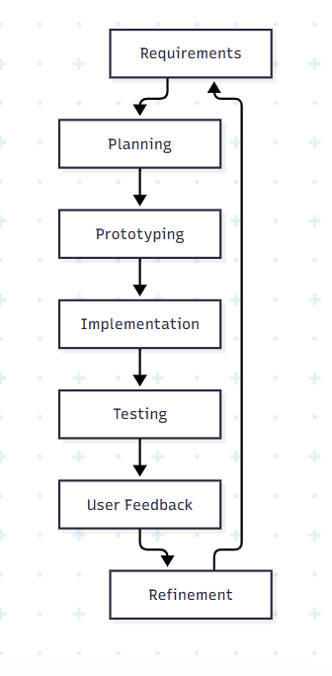
Figure 3.1: Agile Development Cycle

3.2 Requirements Analysis
Requirements were divided into functional requirements, which describe what the system does, and non-functional requirements, which describe system quality and operating conditions.

3.2.1 Functional Requirements
ID | Requirement | Description
FR01 | User registration | The system shall allow HR users and applicants to create accounts.
FR02 | Authentication | The system shall allow registered users to log in with valid credentials.
FR03 | Email verification | The system shall verify email addresses using a one-time password.
FR04 | Password recovery | The system shall support password reset after verification.
FR05 | Role-based access | The system shall provide different permissions for HR administrators, HR managers, employees, applicants, and super administrators.
FR06 | Company onboarding | HR administrators shall register company information.
FR07 | Job management | Authorized HR users shall create, edit, publish, close, and delete job listings.
FR08 | Public job browsing | Applicants shall view available job listings.
FR09 | Applicant profiles | Applicants shall manage personal details, qualifications, skills, experience, education, and availability.
FR10 | Job applications | Applicants shall submit applications and upload CVs and supporting documents.
FR11 | Applicant management | HR users shall search, filter, and review applications.
FR12 | Candidate screening | The system shall generate AI-assisted screening scores and summaries.
FR13 | Application statuses | HR users shall update application statuses.
FR14 | Interview scheduling | HR users shall schedule interviews and add guests.
FR15 | Employee management | HR users shall create, update, search, and deactivate employee records.
FR16 | Departments and locations | Authorized users shall manage departments and office locations.
FR17 | Leave management | Employees shall submit leave requests and HR users shall approve or reject them.
FR18 | Employee self-service | Employees shall access permitted personal, leave, payroll, and document information.
FR19 | Payroll management | HR users shall configure, calculate, approve, and process payroll.
FR20 | Announcements | HR users shall create, schedule, send, update, and delete announcements.
FR21 | Document management | The system shall upload documents and extract text where applicable.
FR22 | Audit logging | Important user and administrative activities shall be recorded.
FR23 | AI assistant | The system shall provide AI-supported recruitment and HR operations.
FR24 | Scheduled tasks | The system shall perform scheduled screening, interview reminders, and maintenance tasks.
FR25 | API monitoring | The system shall provide Swagger API documentation and a health-check endpoint.

3.2.2 Non-Functional Requirements
ID | Requirement | Description
NFR01 | Security | Restricted resources shall require authentication and authorization.
NFR02 | Data privacy | Personal, applicant, employee, and payroll data shall be protected by role and company boundaries.
NFR03 | Usability | The system shall provide clear navigation, forms, messages, and dashboards.
NFR04 | Responsiveness | The interface shall work on desktop, tablet, and mobile screens.
NFR05 | Performance | Normal requests shall be processed within an acceptable time, with pagination for large lists.
NFR06 | Availability | The backend shall provide health monitoring and remain available during normal operation.
NFR07 | Reliability | Invalid input shall be rejected and errors handled appropriately.
NFR08 | Data integrity | Keys, constraints, indexes, and relationships shall maintain consistent data.
NFR09 | Scalability | The system shall support multiple companies, users, jobs, and applicants.
NFR10 | Maintainability | The system shall use modular TypeScript, reusable components, controllers, validation, and migrations.
NFR11 | Interoperability | Frontend and backend shall communicate through REST APIs using JSON.
NFR12 | Portability | The system shall run on compatible Windows or Linux environments with Node.js and PostgreSQL.
NFR13 | Auditability | Administrative actions shall be traceable by user, company, action, metadata, and timestamp.
NFR14 | Extensibility | Additional HR modules and integrations shall be addable without redesigning the core system.
NFR15 | Backup and recovery | Database and uploaded documents should be backed up regularly.
NFR16 | Input validation | Requests shall be checked for required fields, valid formats, types, and permitted values.
NFR17 | Duplicate prevention | Duplicate applications and duplicate payroll entries shall be prevented.

3.3 Input Design
CoreRecruiter uses structured forms to collect, validate, and process information from applicants, HR users, and employees. The main input categories are authentication, company onboarding, job listings, applicant profiles, applications, employees, leave, payroll, interviews, announcements, and document uploads.
Input Form | Main Fields | User
Registration | Name, email, password | Applicant, HR user
Login | Email, password | All users
Company onboarding | Company name, industry, address, country, city, website | HR administrator
Job listing | Title, department, type, level, location, salary, deadline, requirements, skills | HR user
Applicant profile | Name, phone, location, qualification, skills, experience, education, availability | Applicant
Application | Job, expected salary, CV, cover letter, portfolio | Applicant
Employee | Employee ID, name, email, job title, department, office, employment type, phone, joining date | HR user
Leave request | Leave type, dates, reason | Employee
Interview | Title, start time, end time, guests, link, description | HR user
Payroll | Salary, bonus, deductions, currency, payment method, period | HR user
Announcement | Subject, message, recipients, schedule | HR user
Document upload | File name, type, file content | Applicant, employee

Input is validated by the backend before processing. Required fields, email formats, passwords, dates, numeric values, permitted options, duplicate records, and uploaded files are checked. Invalid requests return field-specific errors. The backend uses Zod validation through the validation middleware.

3.4 Output Design
The system produces outputs for applicants, HR users, employees, and administrators. These include HR dashboard summaries, public job listings, applicant profiles, AI screening scores, interview calendars, employee directories, leave statuses, payroll summaries, announcements, reports, audit activities, and validation or authentication messages.
Output screens should be clear, readable, role-specific, and suitable for desktop and mobile use. Recommended screenshots include the HR dashboard, applicant management page, public job listing, employee self-service dashboard, payroll page, and leave page.
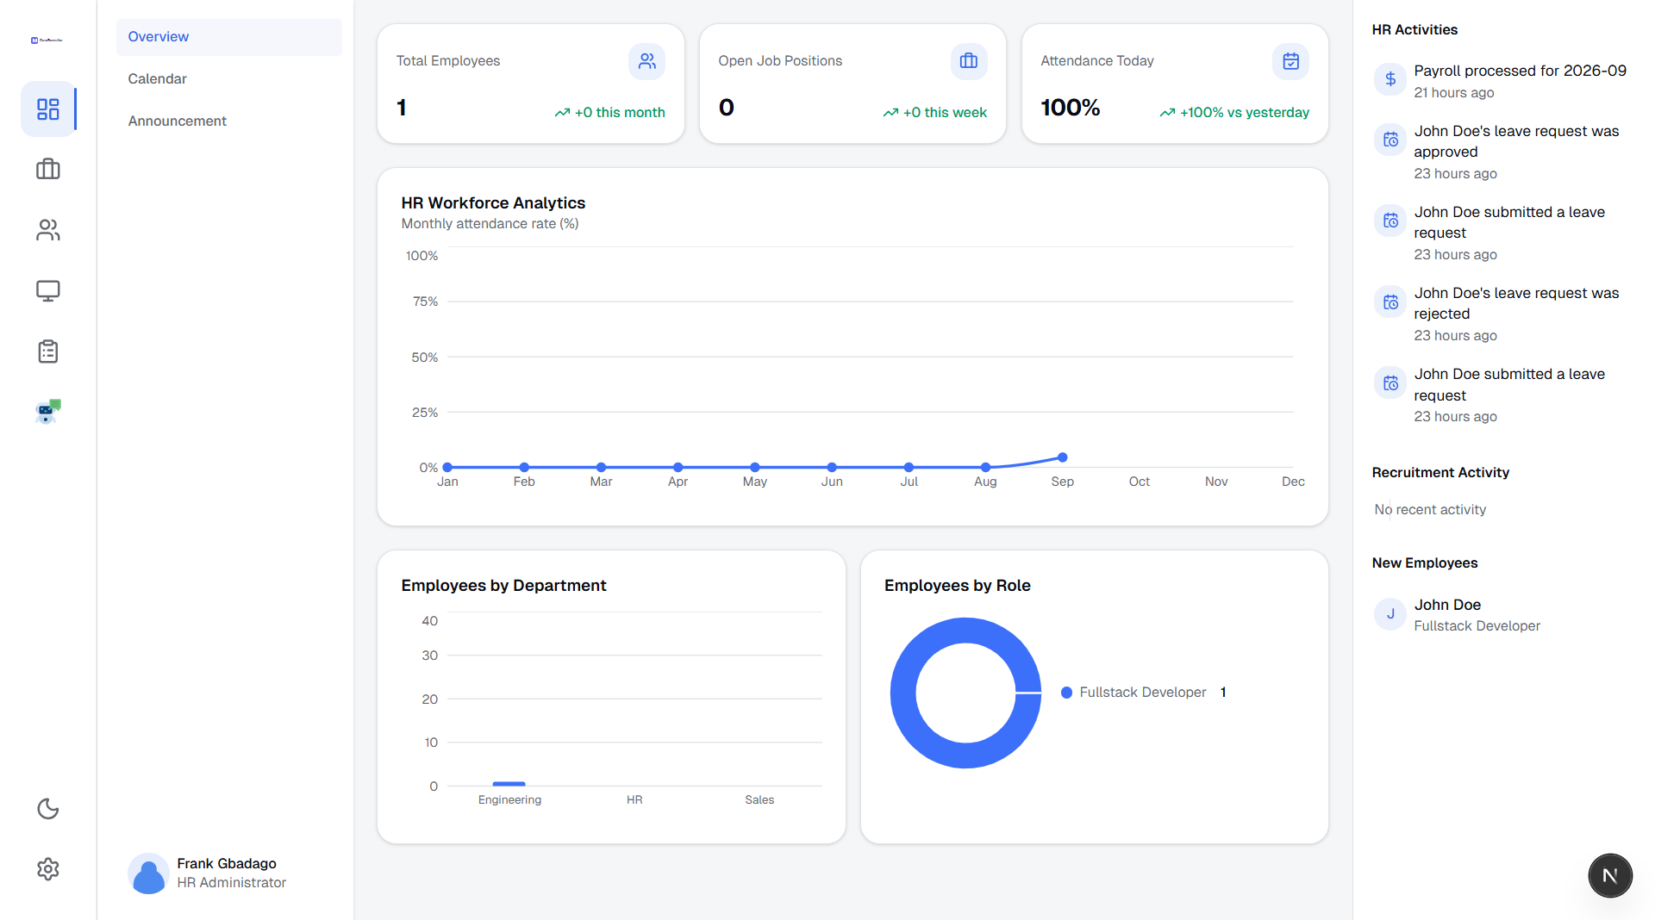
Figure 3.2: Sample Output Screenshots

3.5 Database Design
CoreRecruiter uses PostgreSQL as its relational database and Prisma as its object-relational mapper. The database uses primary keys, foreign keys, enumerated status values, unique constraints, indexes, and migrations.
Major entities include Company, User, Session, Employee, Department, OfficeLocation, Invitation, AuditLog, Job, JobItem, JobSkill, Candidate, CandidateSkill, CandidateExperience, CandidateEducation, Application, ApplicationDocument, Interview, InterviewGuest, LeaveRequest, PayrollRun, PayrollEntry, EmployeeCompensation, PayrollSettings, and Announcement.
Important relationships include:
- One company has many users, employees, departments, jobs, and office locations.
- One department has many employees and jobs.
- One job receives many applications.
- One candidate may apply for multiple jobs.
- One application belongs to one candidate and one job.
- One employee may submit many leave requests and have many payroll entries.
- One payroll run contains many payroll entries.
- One interview may contain many candidate guests.

The complete entity structure is defined in the Prisma schema.

4.1 Entity-Relationship Diagram
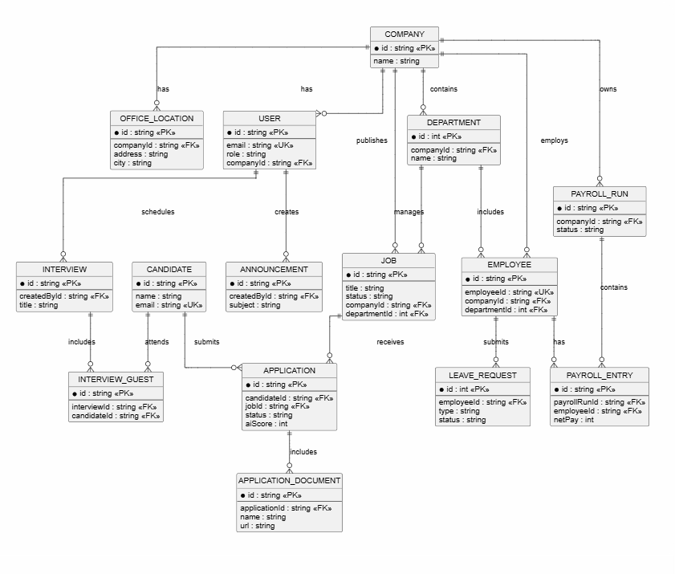
Figure 4.1: Entity-Relationship Diagram

5.1 Use-Case Diagram and Descriptions
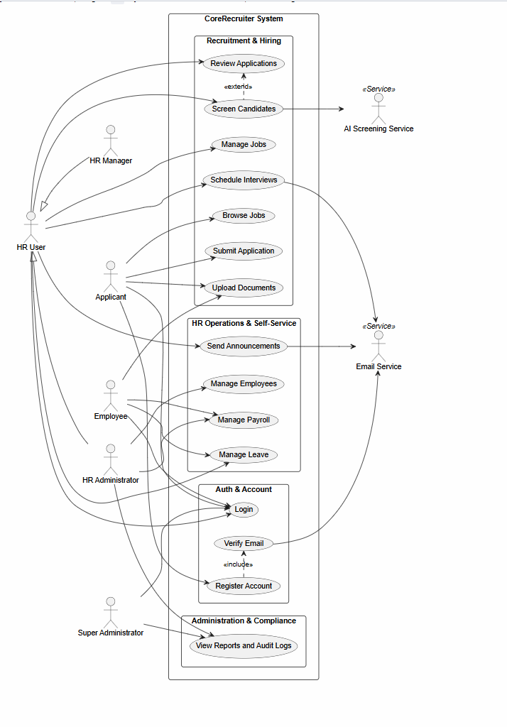.
Figure 5.1: Use-Case Diagram

Use-Case Summaries
Use Case | Actor | Description
User registration | Applicant, HR user | Creates an account and sends an email verification code.
User login | All authenticated roles | Validates credentials and opens the correct dashboard.
Manage jobs | HR administrator, HR manager | Creates, edits, publishes, closes, and deletes job listings.
Submit application | Applicant | Completes an application and uploads supporting documents.
Review applications | HR administrator, HR manager | Searches, filters, views, and updates applications.
Screen candidates | HR administrator, HR manager | Compares candidate information with job requirements and produces a score.
Manage employees | HR administrator | Creates and maintains employee records.
Manage leave | Employee and HR users | Submits, reviews, approves, or rejects leave requests.
Manage payroll | HR administrator | Configures, calculates, approves, and processes payroll runs.
Manage interviews and announcements | HR users | Schedules interviews and sends or schedules announcements.

6. Flowcharts

6.1 Job Application Flowchart
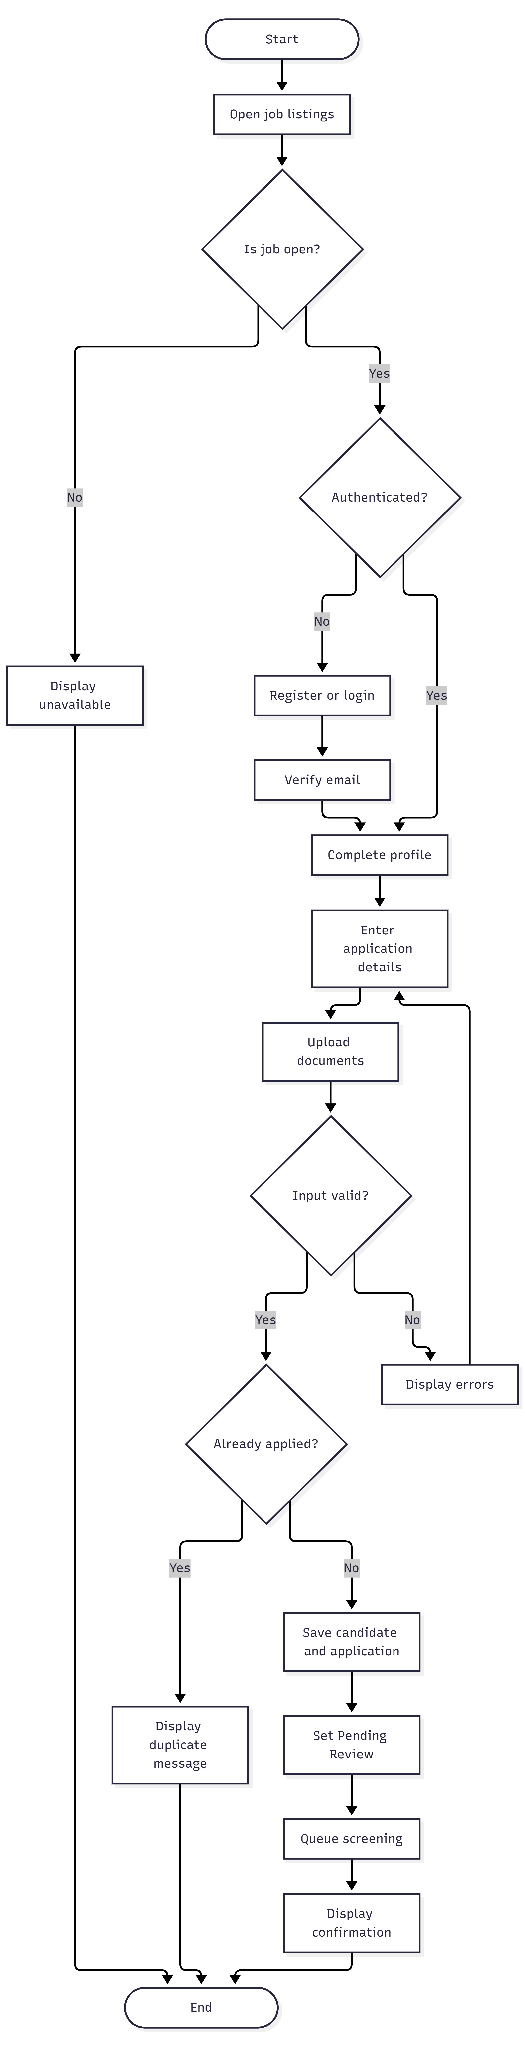.
Figure 6.1: Job Application Flowchart

6.2 Authentication Flowchart
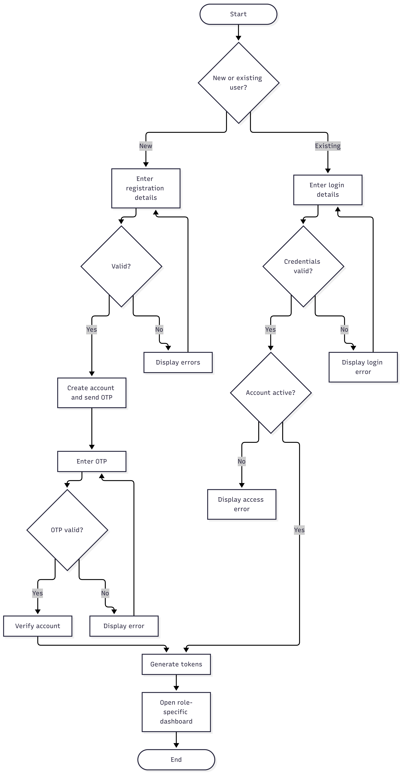
Figure 6.2: Authentication Flowchart

6.3 Leave Request Flowchart
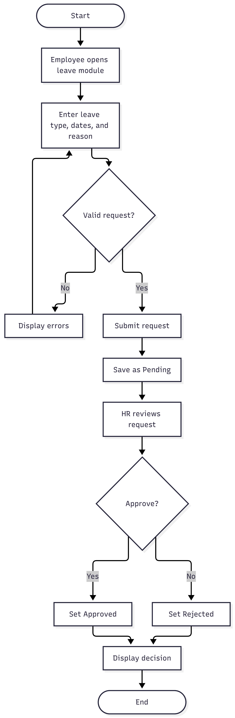.
Figure 6.3: Leave Request Flowchart

6.4 Payroll Processing Flowchart
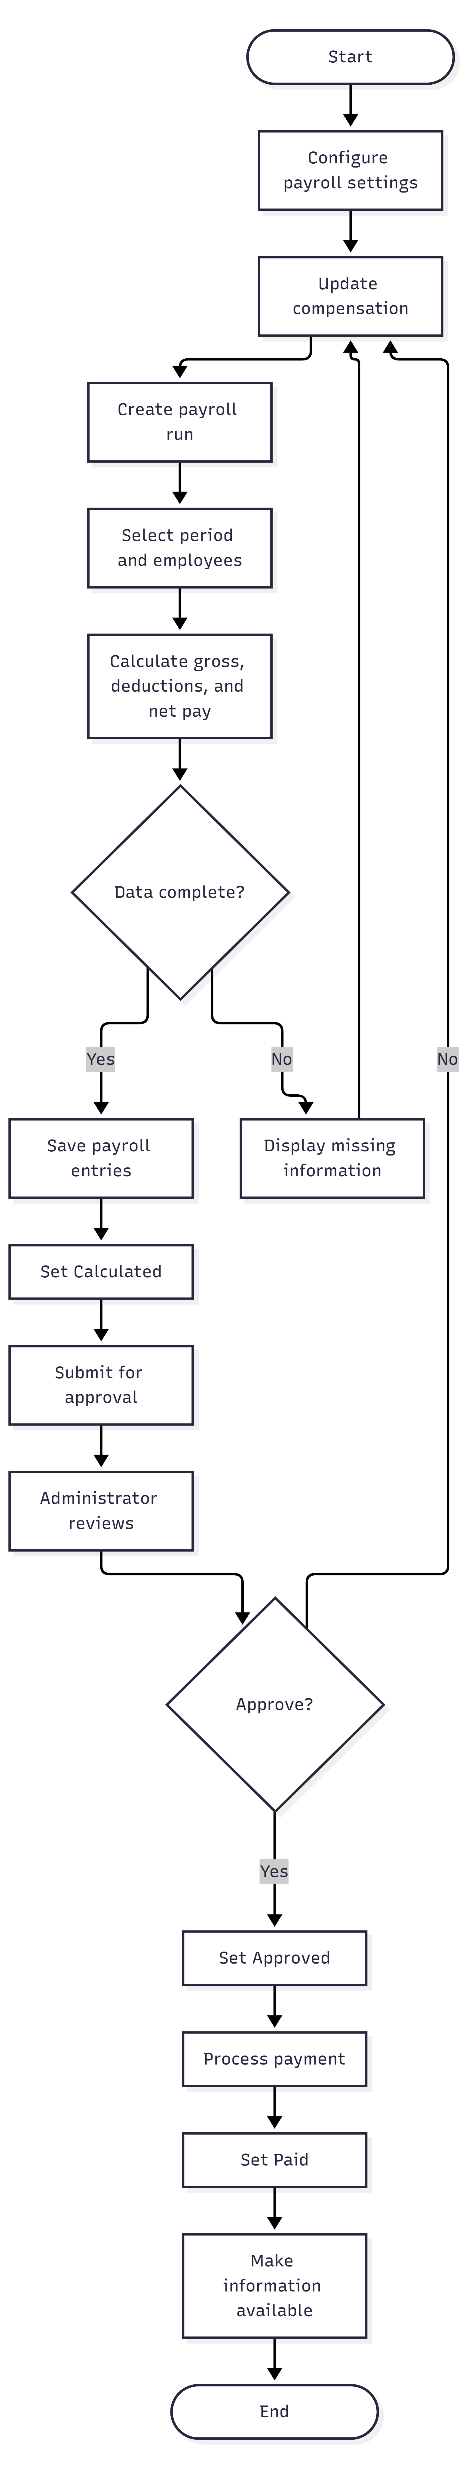
Figure 6.4: Payroll Processing Flowchart

7. Sequence Diagrams

7.1 Login Sequence Diagram
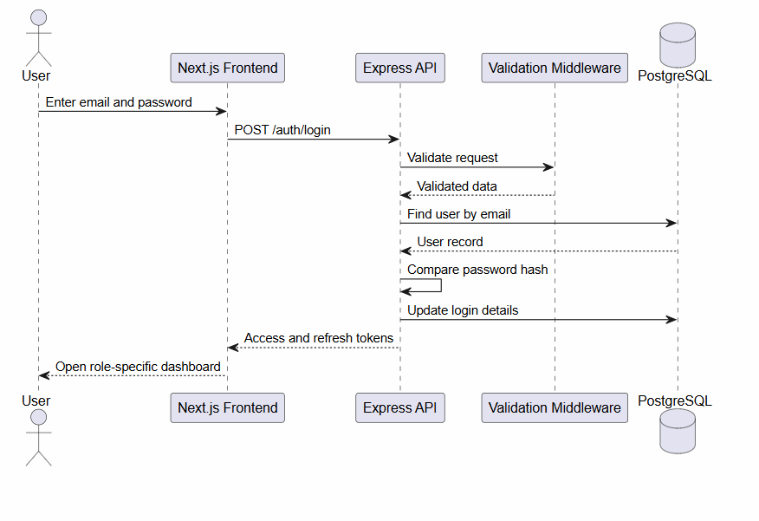.
Figure 7.1: Login Sequence Diagram

7.2 Application Sequence Diagram
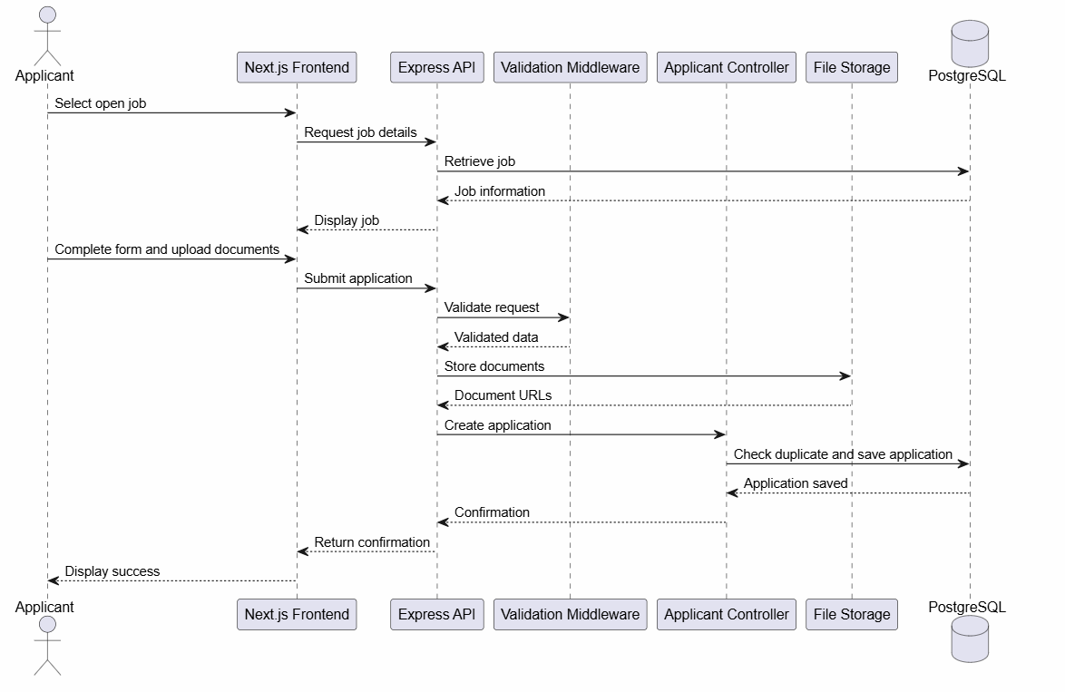
Figure 7.2: Application Sequence Diagram

7.3 AI Screening Sequence Diagram
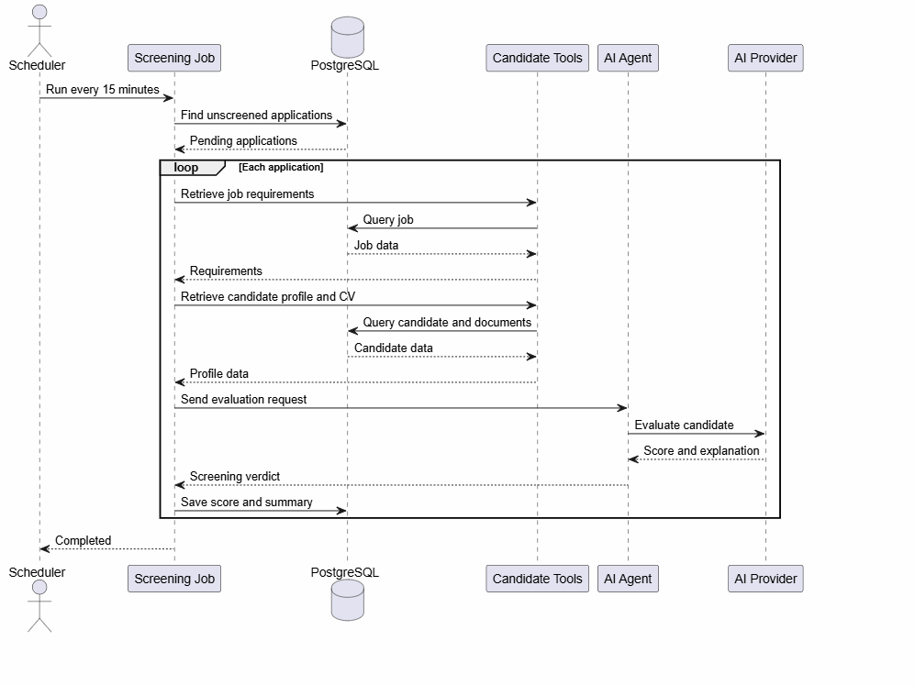
Figure 7.3: AI Screening Sequence Diagram

7.4 Payroll Sequence Diagram
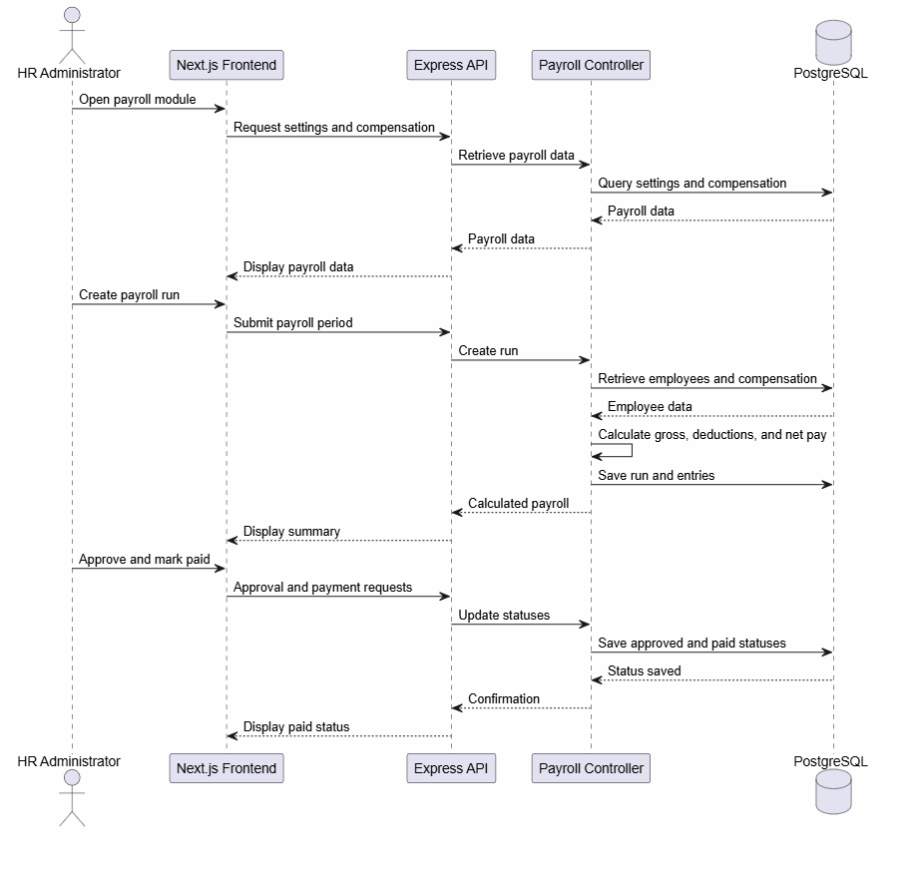
Figure 7.4: Payroll Sequence Diagram

8.1 Backend Class Diagram
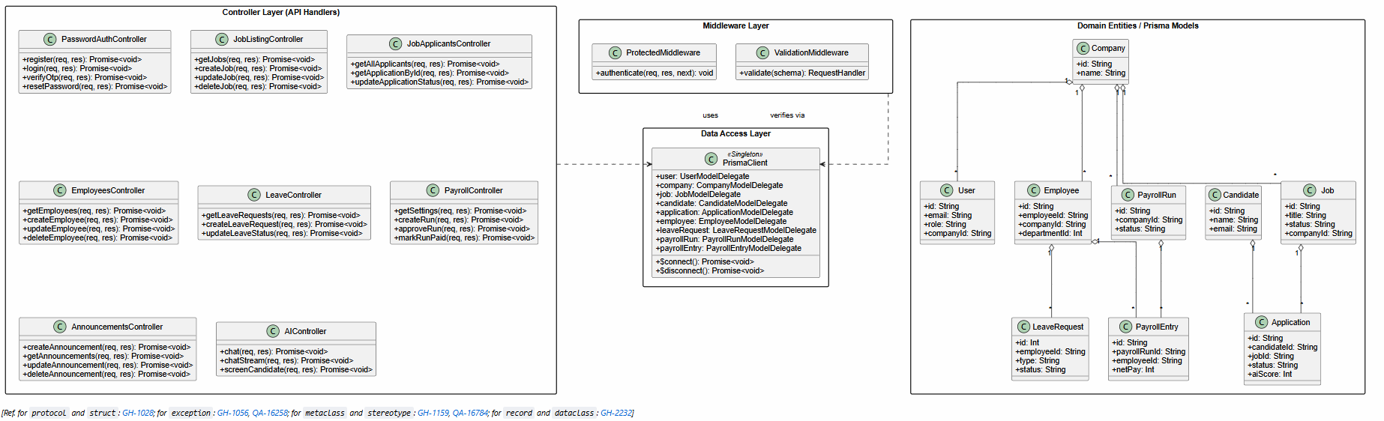
Figure 8.1: Backend Class Diagram
The controllers receive HTTP requests and coordinate operations. Middleware handles authentication, authorization, and validation. Prisma provides access to PostgreSQL, while domain entities represent stored business records.

9. Component Architecture Diagram
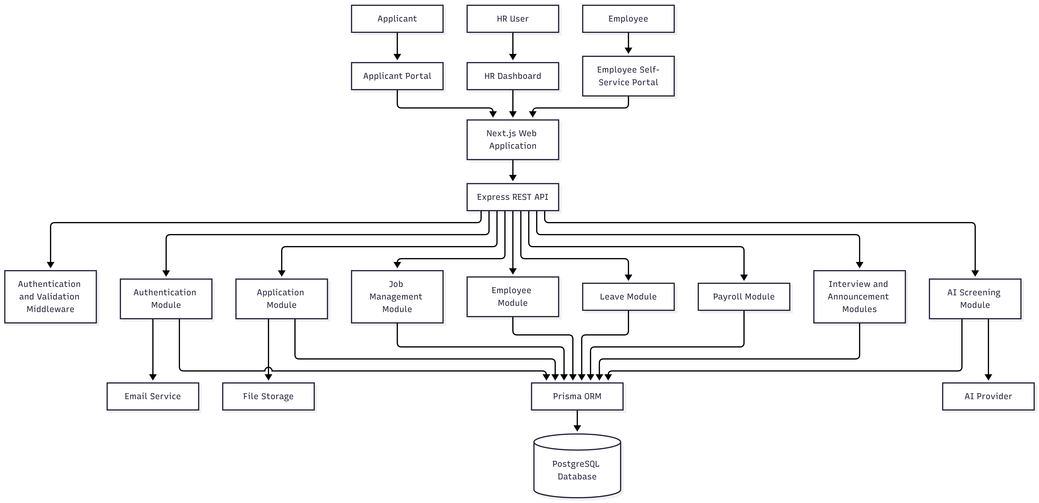
Figure 9.1: Component Architecture Diagram
The architecture separates presentation, business logic, data access, database, and external services. The browser communicates with the API, and external services are accessed by backend modules rather than directly by users.

10. Network and Deployment Design
Figure 10.1: Network and Deployment Diagram
The production network should use HTTPS, restrict direct database access, protect secrets with environment variables, and provide regular database and document backups. The API provides /health for monitoring.

11. Hardware and Software Requirements

11.1 Hardware Requirements
Component | Minimum | Recommended
Processor | Dual-core | Intel Core i5/AMD Ryzen 5 or better
Memory | 8 GB RAM | 16 GB RAM or more
Storage | 10 GB free | 20 GB SSD free
Display | 1366 x 768 | Full HD
Network | Stable internet | Broadband internet
Production server | 2 vCPUs, 4 GB RAM, 25 GB SSD | 4 vCPUs, 8 GB RAM, 50 GB SSD

11.2 Software Requirements
Software | Purpose
Windows, Linux, or macOS | Operating system
Node.js and npm | Runtime and package management
Next.js and React | Frontend application
TypeScript | Frontend and backend development
Express.js | REST API server
PostgreSQL | Relational database
Prisma | Object-relational mapper
Git | Version control
Visual Studio Code | Development environment
Modern web browser | Access and testing
Jest and Supertest | Backend testing
Swagger/OpenAPI | API documentation
Tailwind CSS | Frontend styling

11.3 Supporting Services
Email delivery, Google authentication, file storage, AI services, hosting, and SSL/TLS may be configured for complete production operation. Exact production specifications should only be stated when supported by deployment records.

References to Implementation
- Frontend pages: core-recruiter/app/
- Backend routes: core-recruiter-server1/src/routes/
- Backend modules: core-recruiter-server1/src/Modules/
- Database schema: core-recruiter-server1/prisma/schema.prisma
- API setup: core-recruiter-server1/src/app.ts
- Screening job: core-recruiter-server1/src/jobs/screening.job.ts

CHAPTER FOUR: IMPLEMENTATION AND EVALUATION

4.1 Introduction
This chapter presents the implementation and evaluation of CoreRecruiter. The chapter describes how the system design was converted into a working web application, the test data and procedures used to examine the system, the results of functional testing, and the interpretation of the observed behaviour. Evaluation focused on the main user groups: applicants, HR administrators, HR managers, and employees.
The evaluation was conducted as a controlled functional test using synthetic records. Synthetic data was selected to avoid exposing personal, employment, payroll, or application information while still representing realistic recruitment and human-resource workflows. The results therefore demonstrate system behaviour in the test environment and should not be interpreted as production-scale performance measurements.

4.2 System Implementation

4.2.1 Frontend implementation
The user interface was implemented with Next.js, React, TypeScript, and Tailwind CSS. The application uses the Next.js App Router to organize pages by workflow and user role. The main interface areas are:
- the public job listing and applicant application pages;
- authentication pages for registration, login, email verification, password reset, and password change;
- the HR dashboard for jobs, applicants, employees, leave, payroll, announcements, interviews, and company settings; and
- the employee self-service portal for permitted employee information and requests.

Reusable components were used for navigation, sidebars, forms, cards, modals, filters, avatars, authentication guards, and responsive layouts. This reduced duplication and provided a consistent interaction pattern across the applicant, HR, and employee interfaces. Authentication context and route guards restrict pages according to the current session and user role.

4.2.2 Backend implementation
The backend exposes REST services for authentication, applicants, jobs, employees, departments, attendance, leave, payroll, interviews, announcements, onboarding, uploads, and public jobs. The services receive requests from the frontend, validate input, apply access rules, perform database operations, and return JSON responses.
Authentication and authorization are applied before protected operations. Validation checks required values, formats, permitted status values, dates, numeric fields, and uploaded files. The separation between presentation components, service functions, and server-side business modules makes it possible to modify a user interface without changing the underlying data rules.

4.2.3 Database and external services
PostgreSQL stores the system records, while Prisma provides typed access to the relational schema. Relationships and constraints connect companies, users, jobs, candidates, applications, employees, leave requests, payroll runs, payroll entries, interviews, and announcements. Company identifiers and role checks are used to prevent users from accessing records outside their permitted organization or function.
File uploads are handled through the upload service, email-related operations support verification and notifications, and the AI screening module produces candidate screening information from job and candidate data. These integrations are accessed through application services rather than directly from the browser.

4.2.4 Implemented workflow
The principal implemented workflow is shown below:
[ INSERT DIAGRAM HERE ]
Insert flowchart: User opens web application -> role branch (Applicant portal / HR dashboard / Employee self-service) -> Browse and apply for jobs / Manage recruitment and HR records / Submit and review permitted requests -> REST API -> Validation and authorization -> Prisma data access -> PostgreSQL.
Figure 4.1: Implemented System Workflow

4.3 Experimental Design and Test Data

4.3.1 Evaluation objectives
The evaluation was designed to answer the following questions:
- Can each user role complete the operations assigned to it?
- Are invalid requests rejected with an appropriate response?
- Are authentication, role permissions, and company boundaries enforced?
- Are related records created and displayed consistently across modules?
- Does AI-assisted screening produce a repeatable score and explanation from the supplied candidate and job information?
- Can users understand the main workflow without unnecessary navigation or technical knowledge?

4.3.2 Test environment
Testing was performed against the local development environment using a modern web browser, the Next.js frontend, the REST API, and the PostgreSQL database. The application was exercised through the user interface and through service requests where a backend response needed to be checked directly. The test environment used the project configuration and database schema described in Chapter Three.
The following conditions were kept constant during the functional tests:
- one test company was used for organization-scoped records;
- separate accounts were created for an applicant, HR administrator, HR manager, and employee;
- test records were created before dependent workflows were executed; and
- each test was repeated after an invalid input or unauthorized request to confirm that the invalid operation did not corrupt stored data.

4.3.3 Synthetic test data
Data category | Test data used | Purpose
Accounts | Applicant, HR administrator, HR manager, and employee accounts | Role and authentication tests
Company | One test company with a department and office location | Organization-scoped data tests
Job | An open software-related vacancy with skills, level, location, salary range, and deadline | Job browsing and application tests
Candidate | A candidate profile containing contact details, education, skills, experience, and availability | Applicant and screening tests
Application | One valid application and one attempted duplicate application | Application validation tests
Employee | An employee record with department, job title, employment type, and joining date | Employee management tests
Leave | A request with valid dates and a request with an invalid date range | Leave workflow and validation tests
Payroll | Compensation data, a payroll period, deductions, and a bonus | Payroll calculation and status tests
Interview | An interview title, time range, meeting link, and candidate guest | Interview scheduling tests
Announcement | A subject, message, recipient group, and schedule | Communication workflow tests
Documents | A valid CV file and an unsupported file type | Upload validation tests

The records were intentionally small enough to inspect manually. This made it possible to compare the data entered by the tester with the data returned by the application and database after each operation.

4.4 Functional Test Procedure
Each test began with a defined precondition, followed by an action and an expected result. A test was considered successful when the system produced the expected screen or API response, stored the correct related records, and prevented the specified invalid operation. Tests were reset where necessary so that one scenario did not change the result of another scenario.

4.4.1 Authentication and authorization tests
ID | Test scenario | Expected result | Result
T01 | Register with valid applicant details | Account is created and verification is required | Pass
T02 | Log in with valid credentials | User is authenticated and directed to the correct role area | Pass
T03 | Log in with an incorrect password | Access is refused and an error is displayed | Pass
T04 | Submit an incorrect or expired verification code | Account remains unverified and the user receives an error | Pass
T05 | Open a protected page without authentication | User is redirected or receives an unauthorized response | Pass
T06 | Access an HR-only operation as an employee | Operation is refused | Pass

4.4.2 Recruitment and application tests
ID | Test scenario | Expected result | Result
T07 | Create and publish a job listing as an authorized HR user | Job is saved and appears in the public listing when open | Pass
T08 | Edit or close a job listing | Updated status and details are shown consistently | Pass
T09 | Browse an open job without signing in | Job information is visible without exposing protected HR data | Pass
T10 | Submit an application with valid details and a supported CV | Application and document records are created | Pass
T11 | Submit a second application for the same job and candidate | Duplicate application is rejected | Pass
T12 | Submit an application with missing required fields | Validation errors identify the invalid fields | Pass
T13 | Review and update an application status as HR | Authorized status change is saved and displayed to the applicant or HR user as appropriate | Pass

4.4.3 Employee, leave, and payroll tests
ID | Test scenario | Expected result | Result
T14 | Create an employee record as an authorized HR administrator | Employee is added to the company directory | Pass
T15 | Update an employee record | New values are saved without creating a second employee | Pass
T16 | Submit a valid leave request as an employee | Request is saved with a pending status | Pass
T17 | Submit a leave request where the end date precedes the start date | Request is rejected with a validation message | Pass
T18 | Approve or reject a leave request as HR | Decision is saved and the request status changes | Pass
T19 | Create a payroll run using compensation data | Payroll entries are calculated and associated with the selected period | Pass
T20 | Approve and mark a valid payroll run as paid | Status transitions occur in the permitted order | Pass
T21 | Attempt to process payroll without required compensation data | Operation is blocked and missing data is identified | Pass

4.4.4 Communication, upload, and AI tests
ID | Test scenario | Expected result | Result
T22 | Schedule an interview with a valid time range | Interview and guest information are saved | Pass
T23 | Create and schedule an announcement | Announcement is stored with the selected recipients and schedule | Pass
T24 | Upload a supported document | File is accepted and its reference is associated with the relevant record | Pass
T25 | Upload an unsupported or invalid file | File is rejected without creating an incomplete document record | Pass
T26 | Screen a candidate against a job | Screening score and explanatory summary are returned or stored | Pass
T27 | Request screening without sufficient candidate or job data | Screening is not completed and the missing information is reported | Pass

4.5 Results and Observed Behaviour
The functional tests showed that the main workflows could be completed when valid data and an authorized account were supplied. The system moved information from the user interface through the API and into related database records. For example, creating a job made it available to the applicant-facing listing when the job was open, while submitting an application created an application record connected to both the candidate and the job.
The negative tests were important because a successful HR system must do more than accept valid input. Incorrect credentials, missing fields, invalid dates, duplicate applications, unsupported files, and role-inappropriate actions were rejected. This indicates that validation and access control were applied at the workflow boundary rather than being left only to the visual form controls.
The employee workflow also produced a clear state transition. A valid leave request began in a pending state, and an authorized HR decision changed it to approved or rejected. Similarly, payroll records moved through controlled stages rather than being presented as paid immediately after creation. These transitions make the current state of an administrative operation visible and reduce ambiguity for users.
The AI screening test produced a score and an explanatory result when the job requirements and candidate information were sufficiently complete. The explanation is useful because it gives HR users context for the score instead of presenting an unexplained number. However, the screening output is decision support and should be reviewed by a qualified HR user. It does not replace human judgment or establish that a candidate is suitable for employment.

4.6 Analysis and Interpretation

4.6.1 Functional completeness
The results indicate that the implemented system covers the principal functional requirements identified in Chapter Three. Authentication, job management, applications, employee management, leave, payroll, announcements, interviews, uploads, and AI-supported screening are represented in the application structure and can be evaluated through role-specific workflows. The use of separate services and reusable interface components supports maintainability because each functional area has a recognizable implementation boundary.

4.6.2 Security and data integrity
The authorization tests demonstrate the importance of checking identity and role on the server side. A hidden button alone would not protect payroll or employee information, because a user could still attempt to call the endpoint directly. The observed rejection of protected and role-inappropriate operations shows that the security boundary is enforced during request processing.
Relational links and duplicate checks also contributed to data integrity. Applications were associated with a candidate and a job, payroll entries were associated with a run and an employee, and leave requests were associated with an employee. Rejecting duplicate applications and incomplete payroll operations prevents common inconsistencies that would otherwise affect reporting and administrative decisions.

4.6.3 Usability and responsiveness
The role-specific navigation reduced the amount of information presented to each user. Applicants primarily encounter jobs and applications, employees encounter self-service functions, and HR users encounter administrative modules. Clear validation messages and visible statuses support recovery when a user submits incomplete or invalid information. Responsive layouts allow the main workflows to remain usable on desktop, tablet, and mobile viewport sizes, although detailed payroll and applicant review are more suitable for larger screens.

4.6.4 AI screening interpretation
The AI screening feature addresses the time required to compare candidate information with job requirements. Its useful observation is not only the score but also the relationship between the score, the supplied skills, experience, and requirements. Incomplete input produces a weaker basis for evaluation, which explains why the system must validate the presence of candidate and job information before screening.
The screening result may be affected by the quality, completeness, and wording of the source data. It may also reproduce biases present in the requirements or training and provider behaviour. Consequently, the appropriate interpretation is that the feature assists prioritization and review. Final recruitment decisions require human verification, consistent criteria, and compliance with applicable employment policies.

4.7 Evaluation Against the Objectives
Objective | Evaluation finding
Provide role-based recruitment and HR workflows | Achieved through applicant, HR, and employee areas with protected operations.
Support job publishing and applications | Achieved through job listing, application, document, duplicate, and status workflows.
Improve administrative record management | Achieved through connected employee, leave, payroll, interview, and announcement records.
Protect sensitive information | Addressed through authentication, authorization, validation, and company-scoped data access.
Assist candidate screening | Achieved as an AI-supported score and summary subject to HR review.
Provide a usable responsive interface | Supported by reusable responsive components and role-specific navigation.
Maintain reliable and valid data | Addressed through relational constraints, status transitions, validation, and duplicate prevention.

4.8 Limitations of the Evaluation
The evaluation used a local test environment and synthetic data. It did not measure long-term availability, production traffic capacity, large-file upload performance, or behaviour under simultaneous use by many organizations. It also did not constitute an independent audit of security, fairness, or legal compliance.
The AI screening evaluation was functional rather than a statistical validation study. A larger labelled candidate dataset and an agreed human-review benchmark would be required to measure precision, recall, agreement with HR reviewers, and possible demographic bias. These limitations define the boundary of the conclusions: the tests show that the implemented workflows operate as designed under the selected scenarios, but they do not prove that every possible input or production condition has been handled.

4.9 Chapter Summary
This chapter presented the implementation and evaluation of CoreRecruiter. The system was implemented as a Next.js and React frontend connected to REST services, Prisma, PostgreSQL, file handling, email-related operations, and AI-assisted screening. Synthetic test data was used to evaluate authentication, authorization, recruitment, applications, employee management, leave, payroll, communication, document uploads, and screening.
The observed results show that valid workflows were completed and that important invalid or unauthorized operations were rejected. The findings support the system's functional objectives while also showing that production deployment would require further load, security, usability, and AI fairness evaluation. The next chapter can discuss the conclusions, contributions, recommendations, and opportunities for future improvement.

CHAPTER FIVE: CONCLUSION AND FUTURE WORK

5.1 Introduction
This chapter concludes the development and evaluation of CoreRecruiter. It summarises the results presented in Chapter Four, relates those results to the aim and objectives of the study, makes recommendations for use and improvement, and identifies areas for future work. The conclusions are based on functional tests conducted with synthetic data in a local development environment. They therefore describe what was demonstrated by the implemented system under the selected test conditions and do not claim that all production, legal, scalability, usability, or fairness requirements have been fully established.

5.2 Summary of Results
The project designed and implemented CoreRecruiter as an integrated web-based recruitment and human resource management platform. The system combines an applicant portal, an HR administration dashboard, an employee self-service portal, and an AI-assisted candidate screening feature. The implementation used a Next.js and React frontend, TypeScript services, REST communication, PostgreSQL, Prisma, file upload services, email-related operations, and role-based authentication and authorization.
The principal results were as follows:
- Integrated recruitment workflow: Applicants can browse open jobs, provide profile information, submit applications, upload supporting documents, and receive application-related status information. HR users can create and manage job listings, review applications, update application statuses, and schedule interviews.
- HR administration: The system provides connected workflows for employee records, departments, office locations, leave requests, payroll, announcements, interviews, and documents. These records are linked through the database rather than being maintained as isolated forms.
- Employee self-service: Employees can access permitted information and submit requests such as leave applications. HR users can review and decide on those requests, making the resulting status visible in the workflow.
- Validation and data integrity: Required fields, dates, permitted values, duplicate applications, compensation data, and uploaded file types are checked before processing. Relational links, unique constraints, and controlled statuses help prevent inconsistent records.
- Security and access control: Authentication, role checks, and company-scoped access restrict protected operations. The tests showed that unauthenticated users and users without the required role were refused access to protected actions.
- AI-assisted screening: The screening feature produces a score and an explanatory result when adequate candidate and job information is supplied. This supports HR review by providing more context than an unexplained aggregate score. The feature remains decision support and does not replace human judgement.

The functional evaluation included 27 scenarios covering authentication, authorization, recruitment, applications, employee management, leave, payroll, interviews, announcements, document uploads, and AI screening. All scenarios were recorded as passing in the test results. The negative tests were especially significant: incorrect credentials, invalid verification details, missing fields, duplicate applications, invalid leave dates, unsupported files, incomplete payroll data, and role-inappropriate operations were rejected as expected.

5.3 Conclusion Against the Objectives
The overall aim was to design and develop an integrated, AI-assisted recruitment and HR management platform suited to the Ghanaian SME context. The implementation and functional results indicate that this aim was substantially achieved at prototype and functional-system level.
The stated objectives can be concluded as follows:
Objective | Conclusion | Basis of conclusion
Review existing recruitment and HRIS tools and relevant theory | Achieved at the study level | The project identified the gap between recruitment and post-hire administration and used e-HRM, Technology Acceptance Model, and Person–Job/Person–Organisation Fit concepts to frame the system.
Design an architecture and data model connecting applicant and employee information | Substantially achieved | The frontend, REST services, Prisma access layer, and PostgreSQL relationships provide connected records across recruitment and HR modules. A larger production integration test would be needed to verify every transition.
Implement job listings, applications, and status tracking | Achieved | Job creation, public browsing, valid application submission, duplicate prevention, document handling, and application status tests passed.
Implement explainable AI-assisted screening | Functionally achieved with limitations | The system returned a score and explanatory summary for sufficiently complete data. Statistical accuracy, repeatability across large datasets, and fairness were not established by the functional test.
Implement the HR administration dashboard | Achieved for the evaluated workflows | Employee, leave, payroll, interview, announcement, job, and applicant workflows were represented and tested.
Implement employee self-service | Achieved for the evaluated workflows | Employee access and leave request workflows were included, with HR approval or rejection producing a visible state change.
Implement authentication, role-based access, and data handling controls | Functionally achieved | Authentication and role-inappropriate access tests passed, while company identifiers and relational boundaries were used in protected operations. An independent security audit remains necessary.
Evaluate the system against the objectives | Achieved at functional-test level | Twenty-seven synthetic-data scenarios passed in the local test environment. Usability, load, production resilience, and AI fairness require additional evaluation.

The conclusion is therefore positive but bounded. CoreRecruiter demonstrates that an integrated recruitment-to-HR workflow can be implemented with role-specific interfaces, connected records, validation, controlled status transitions, and AI-assisted screening. The results do not prove that the platform is ready for unrestricted production deployment or that the AI output is free from bias.

5.4 Justification of the Conclusions
The conclusions are justified by the relationship between the test procedures, observed results, and stated limitations. Each test began with a precondition and defined action, then checked the resulting screen, response, or stored record. This provided direct evidence that the main user roles could complete the selected operations and that invalid operations did not produce the intended protected or incomplete records.
The conclusion about functional completeness is supported by the breadth of the 27 scenarios. The tests covered the major modules rather than only the public job page or authentication flow. For example, a job could be created and made visible to applicants, an application could be linked to a candidate and a job, leave could move from pending to an HR decision, and payroll could follow controlled status changes. These observations support the conclusion that the modules are connected through a working application and data layer.
The conclusion about security is narrower. The rejection of unauthenticated and role-inappropriate actions demonstrates that access checks operate during request processing in the tested cases. It does not constitute a penetration test, a formal privacy compliance assessment, or proof that every endpoint and deployment configuration is secure. The conclusion about data integrity is similarly supported by validation, relationships, duplicate checks, and status tests, but should be confirmed under larger and more varied datasets.
The conclusion about AI screening is based on successful functional output: the system produced a score and explanation when the required candidate and job information was present and refused or reported insufficient information when it was not. This supports the claim that the feature is implemented and usable as decision support. It does not support claims about hiring accuracy, reduced bias, agreement with HR experts, or improved recruitment outcomes because those measures were outside the scope of the evaluation.

5.5 Recommendations
The following recommendations arise from the implementation results and the limitations of the evaluation:
- Use human review for recruitment decisions. HR users should treat AI screening scores and explanations as prioritisation aids. Final decisions should be based on documented criteria, human review, interviews, and applicable organisational policies.
- Maintain complete and consistent source data. HR teams and applicants should provide accurate job requirements, skills, education, experience, and supporting documents. Screening quality depends on the completeness and wording of this information.
- Apply least-privilege access. Each organisation should review role permissions, company boundaries, administrative accounts, and audit logs before deployment. Access to payroll, employee documents, and applicant information should be limited to users who require it for their duties.
- Establish data protection procedures. Before operational use, the organisation should define retention periods, consent and privacy notices, correction procedures, deletion or archival rules, backup controls, and incident-response responsibilities in line with applicable data-protection requirements.
- Pilot the system with a small HR team. A controlled pilot with representative HR users can identify workflow, terminology, connectivity, and training issues that synthetic functional tests cannot reveal.
- Monitor the system after deployment. Administrators should monitor failed requests, response times, database health, upload failures, audit activity, backup success, and screening outcomes. Monitoring should be paired with a clear process for correcting inaccurate records.
- Document organisational policies in the configuration. Leave rules, payroll periods, approval authority, application statuses, interview procedures, and announcement groups should be configured and documented consistently for each organisation.

5.6 Future Work
Future work should extend both the system and the evidence used to evaluate it:
- Usability evaluation: Conduct moderated usability tests and interviews with HR administrators, HR managers, employees, and applicants. Measures such as task completion time, error rate, perceived usefulness, perceived ease of use, and user satisfaction would provide evidence beyond developer-led functional testing.
- Production and scale testing: Deploy the system in a controlled staging environment and measure concurrent users, API response times, database performance, queue or scheduled-task behaviour, large-file handling, and recovery after service interruption.
- Security and compliance assessment: Perform threat modelling, dependency review, authorization testing, penetration testing, secure configuration review, and an assessment against applicable Ghanaian data-protection obligations.
- AI validation and fairness monitoring: Build a sufficiently large, representative, and appropriately governed labelled dataset. Compare screening results with qualified HR reviewers, measure agreement and error patterns, test repeatability, and monitor outcomes across relevant groups without using protected characteristics improperly.
- Improved explainability: Preserve the criteria, source fields, score components, model or provider version, and timestamp used for each screening result. This would make later review and audit more reliable.
- Applicant-to-employee automation: Extend the tested workflow so that an accepted candidate can be converted into an employee record with verified information and explicit user confirmation, while preventing unnecessary duplication and preserving the application history.
- Infrastructure resilience: Add stronger offline or low-bandwidth handling where practical, background retries for non-critical notifications, automated backups, disaster recovery exercises, and documented deployment procedures suitable for organisations with limited technical support.
- Additional integrations: Evaluate integrations with payroll providers, calendar services, identity providers, email delivery services, and local reporting requirements only after privacy, security, and data ownership responsibilities have been defined.

5.7 Final Conclusion
CoreRecruiter addresses the central problem identified in this study by bringing recruitment, applicant management, HR administration, employee self-service, and AI-assisted screening into one web-based platform. The implementation shows that the proposed workflow can be supported by a modular frontend, REST services, a relational data model, validation, role-based access control, and connected records.
The evaluation provides evidence that the principal workflows operated correctly for the selected synthetic scenarios and that important invalid or unauthorized actions were rejected. It also shows the value of an explanatory screening result: HR users receive a basis for review rather than only an opaque number. Nevertheless, the system should be understood as a functionally evaluated platform rather than a fully validated production service. Larger datasets, real users, security assessment, load testing, privacy review, and AI fairness monitoring are required before strong claims about operational impact or responsible large-scale deployment can be made.
The project therefore makes a practical contribution by demonstrating an integrated and extensible foundation for recruitment and HR administration in the Ghanaian SME context. Its strongest conclusion is not that technology removes the complexity of HR decision-making, but that a carefully structured system can make those workflows more connected, traceable, and reviewable while leaving consequential decisions under accountable human oversight.

References
Albaroudi, E., Mansouri, T., & Alameer, A. (2024). A comprehensive review of AI techniques for addressing algorithmic bias in job hiring. AI, 5(1), 383–404. https://doi.org/10.3390/ai5010019
Amoako, R., Jiang, Y., Adu-Yeboah, S. S., Frempong, M. F., & Tetteh, S. (2023). Factors influencing electronic human resource management implementation in public organizations in an emerging economy: An empirical study. South African Journal of Business Management, 54(1), Article a2937. https://doi.org/10.4102/sajbm.v54i1.2937
Bandara, R. J., Biswas, K., Akter, S., Shafique, S., & Rahman, M. (2025). Addressing algorithmic bias in AI-driven HRM systems: Implications for strategic HRM effectiveness. Human Resource Management Journal. https://doi.org/10.1111/1748-8583.12609
Bondarouk, T., Parry, E., & Furtmueller, E. (2017). Electronic HRM: Four decades of research on adoption and consequences. The International Journal of Human Resource Management, 28(1), 98–131. https://doi.org/10.1080/09585192.2016.1245672
Căvescu, A. M., & Popescu, N. (2025). Predictive analytics in human resources management: Evaluating AIHR’s role in talent retention. AppliedMath, 5(3), 99. https://doi.org/10.3390/appliedmath5030099
Data Protection Act, 2012 (Act 843) (Ghana). https://www.dataprotection.org.gh/data-protection-act
Davis, F. D. (1989). Perceived usefulness, perceived ease of use, and user acceptance of information technology. MIS Quarterly, 13(3), 319–340. https://doi.org/10.2307/249008
Gan, C., Zhang, Q., & Mori, T. (2024). Application of LLM agents in recruitment: A novel framework for resume screening. arXiv. https://arxiv.org/abs/2401.08315
Hilliard, A., Guenole, N., & Leutner, F. (2022). Robots are judging me: Perceived fairness of algorithmic recruitment tools. Frontiers in Psychology, 13, Article 940456. https://doi.org/10.3389/fpsyg.2022.940456
Kristof, A. L. (1996). Person–organization fit: An integrative review of its conceptualizations, measurement, and implications. Personnel Psychology, 49(1), 1–49. https://doi.org/10.1111/j.1744-6570.1996.tb01790.x
Kristof-Brown, A. L., Zimmerman, R. D., & Johnson, E. C. (2005). Consequences of individuals’ fit at work: A meta-analysis of person–job, person–organization, person–group, and person–supervisor fit. Personnel Psychology, 58(2), 281–342. https://doi.org/10.1111/j.1744-6570.2005.00672.x
Nasar, N., & Ray, S. (2024). A user acceptance model for e-HRM system implemented in IT and non-IT business organizations. Human Systems Management. https://doi.org/10.3233/HSM-220177
Noutsa Fobang, A., Fosso Wamba, S., & Kala Kamdjoug, J. R. (2019). Exploring factors affecting the adoption of HRIS in SMEs in a developing country: Evidence from Cameroon. In Y. K. Dwivedi, E. L. Slade, M. A. Shareef, M. Bunker, & A. Rana (Eds.), Information systems (pp. 237–248). Springer. https://doi.org/10.1007/978-3-030-10737-6_18
Quaosar, G. M. A. A., & Rahman, M. S. (2021). Human resource information systems (HRIS) of developing countries in 21st century: Review and prospects. Journal of Human Resource and Sustainability Studies, 9(3), 470–483. https://doi.org/10.4236/jhrss.2021.93030
Twinamasiko, F. (2026). Electronic human resource management (E-HRM) and recruitment & selection effectiveness: Enhancing efficiency, transparency, and decision quality. East African Journal of Business and Economics, 9(1), 76–89.
Webster, K. T. (2025). Fairness is not enough: Auditing competence and intersectional bias in AI-powered resume screening. arXiv. https://arxiv.org/abs/2507.11548

